sf4m treasury

# a field guide by: Rebecca Sadique

*As the treasurer of the Stony Brook Science Fiction Forum, it is your duty to ensure that the club’s funds are spent responsibly. It is your duty to ensure that our club isn’t breaking any of the Financial Bylaws set by USG when our funds are being spent.*

General advice

Read the Financial Bylaws.

Seriously. Read through all of them this summer and get well acquainted. This is **VERY important**. It’s probably the most important thing you do as treasurer, make sure to double and triple check that vouchers and grants are in line with the Financial Bylaws. You can find a link to the bylaws and other helpful things here: <http://stonybrookusg.org/treasury-clubs-organizations-help-page/>

Make everyone use the Request Form, even if they don’t want to.

It will make your job so much easier, seriously. You’ve got the hardest job on eboard, if people can’t take 2 minutes to put things in the request form then they can suck it. No more rifling through the request book struggling to read bad handwriting and having to look up links and prices for each individual item yourself. It is also very helpful to the library because it is a timestamped record of new additions to our collection. No need to create a separate spreadsheet or look through old meeting notes/vouchers, it’s all there in one document. I the request form, always.

Do only your job and nothing else.

And for the sake of your own sanity, do NOT do treasurer things in the forum. The forum is a place for fun times and friends and you’re gonna need these things because you’re the treasurer and boy is this job FUN! Seriously. Don’t be a shiftholder, don’t be a sub AC. Just don’t. You have the shittiest job on eboard. Don’t make it any worse for yourself. I learned this the hard way, that it really takes a toll on you. Help out when you can but don’t take on any more obligations than you already have (and you have a lot, trust me). Don’t take on more than you can handle.

Do NOT fuck up deadlines.

Vouchers, grants, and budget applications are very important to get in on time. Not even on time. EARLY. Submitting any of these late is REALLY BAD for our club. The USG website will usually have a list of important treasury deadlines, mark these dates down in your calendar and share any relevant deadlines with your eboard so you can all plan accordingly.

Work with your Head AC

Your Head AC is in charge of planning and running events. Attend any Sub AC meetings in which your Head AC is deciding on what items/food to buy for event(s) and be there to advise them on what is and isn’t kosher to spend our line budget on. What worked really well this year was planning out all event allocations at the very beginning of the semester and creating the vouchers early. Start making allocations for Shriek Week and Festivus within the first few of weeks of the semester.

Talk to your eboard

Try to have more than just the one weekly eboard meeting next semester. This year having eboard meeting before our general body meeting simply wasn’t enough because we had so much to talk about. If you have problems with someone on your eboard or they’re not pulling their weight, be direct and talk to them about it. It’s important to remember that you’re all only human and mistakes will happen once in a while. Be solution-oriented and focus on fixing the mistake rather than dwelling on things. Attitude is everything.

Ask for help

If things are piling up and you need someone to make a voucher or pick up a check, ask your Vice President (or anyone on eboard, really). If you have treasury questions, contact the older 4m treasurers. I’m only a facebook message away, and James Bylicky will physically be there to help you! He helped me a lot when I was starting out and I’m sure he’ll do the same for you, what a doll he is.

Campusvine

1. **NON EVENT VOUCHERS**: Any time you spend money and items you are purchasing are NOT for an event. For example: vouchers for adding to our book, DVD, comic, and board game collections or purchasing things for the lounge/library (ex: storage boxes, tape, sharpies).
   1. Log on to campusvine.com
   2. Click “Allocate”
   3. Under “Banana Stand” click “Create Allocation”
   4. A drop down menu with 3 options will appear:
      1. **Direct Pay**: select this option if you need to buy things in-store.
      2. **Online Order**: select this option if you want to order things online.
      3. **Reimbursement**: select this option when somebody spends their own money and needs USG to pay them back. Make sure they are a reimbursable user on campusvine and make sure they have a receipt for any purchases made.
   5. The first item on the voucher should be a drop down menu titled “Budget.” Select the appropriate budget in the first drop down menu on the voucher page (ex: over the summer I selected “Summer 2” but over the academic year I selected “2015-2016 Academic year” it ain’t hard)
   6. IF THE VOUCHER IS A:
      1. Direct Pay:
         * Select “pick up check” and USG will print you out a check for pick up. After picking up the check you have **1 week** to purchase the items and return the receipt to the USG front desk. REMEMBER TO SAVE & SCAN RECIEPTS.
      2. Online Order
         * Always select “mail check”
      3. Reimbursement
         * FIRST. Have you filled out the reimbursement request form? Has it been pre-approved? If not, go do that. You can find it here: <http://stonybrookusg.org/treasury-clubs-organizations-help-page/>
         * You can either select “pick up check” or “mail check” depending on how the person being reimbursed wants to get their check
         * Instead of a list of vendors, there will be a list of reimbursable users, select a user.
   7. Enter the justification for your voucher – why does your club need the item(s) listed?
   8. If your order is a direct pay or online order, search for and select your vendor under the section titled “Vendor.” If your order is a reimbursement, select your reimbursable user
   9. 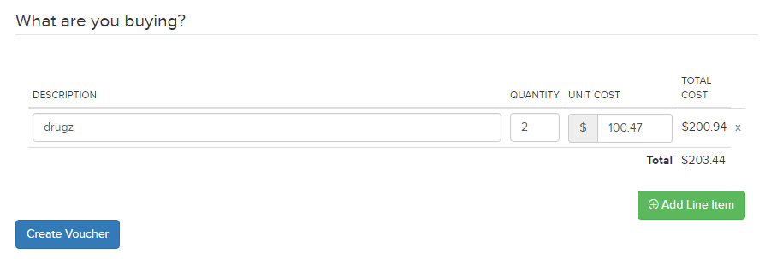Under the “What are you buying?” section, put down the name of the item you want to buy, the quantity, and the cost of each individual item. This is how it should look:
   10. Select “Create Voucher”
   11. 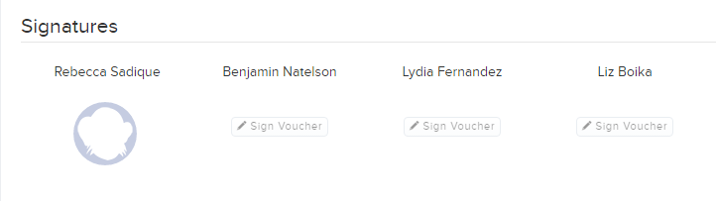Once the voucher is created, sign the voucher by scrolling to the bottom of the page and selecting “Sign Voucher” under your name. This is how it should look:



1. **EVENT VOUCHERS**: Create an event voucher any time you will be spending money that goes towards an event.

* Log onto campusvine
* Click “Allocate”
* 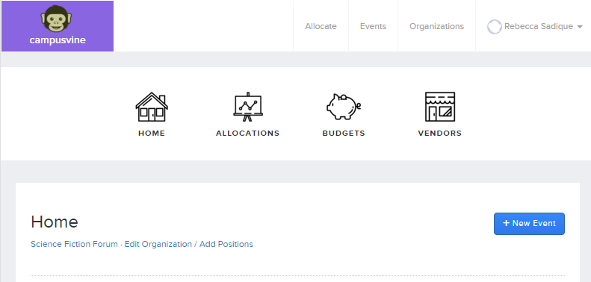Click “New Event” (the button is located towards the right of the page)



* Enter the Name, Location, Date, Time, and Description for the event.
* Select “Create Event”
* Under the event page, select “Create Allocation”
* Follow steps #4-11 under the **NON EVENT VOUCHERS** section above
* Be sure to create an event page for ALL events so that future eboards can look at old vouchers if they need help, looking at old vouchers helped me A LOT this year.

**IMPORTANT:**

There are a lot of steps in the voucher process which is why you need to make and SIGN each voucher at least 3 weeks before you need any items you are allocating for. Just look. Look at all the steps below. There are so many.

Club approval 🡪 Administrative Director Approval 🡪Treasurer Approval 🡪 Fiscal Agent Approval 🡪 Bookkeeper processing 🡪 Pending Order Placement 🡪 Pending Order Delivery 🡪 Delivery Ready for Pickup 🡪 Complete

Be sure to keep checking the status of your vouchers so that you know when your order is ready for pick up or your check has printed. If there is something wrong with the voucher, someone from accounting will usually post a comment on the voucher. Check up on vouchers as often as you can.

Spring budget application

The spring budget application is the most important thing you’ll do as treasurer because it directly affects our budget for the following semester. Unfortunately, the application changes when there is a new USG treasurer so your application may look different from mine. I have uploaded a copy of this year’s spring budget application to the sf4m gmail drive.

This year we attended every treasury meeting and got priority scheduling for our budget hearing. IT IS VERY IMPORTANT THAT YOU DO THIS AS WELL SO THAT YOUR EBOARD CAN PICK THE DATE/TIME THAT WORKS BEST FOR THEM. Make sure that all signatory eboard members show up to the budget hearing dressed nicely and know the entire application because USG senators will grill you. Eboard members not showing up looks bad. Real bad. Do not allow signatories to flake on budget hearings next year. USG will tell you that it’s only mandatory for 2 signatories to show up, but make sure everyone shows up. Even non-signatories if you can swing it.

**GETTING A VOUCHER APPROVED AROUND THE SPRING BUDGET APPLICATION DUE DATE AND DURING BUDGET HEARINGS IS PAINFULLY SLOW, CREATE THOSE VOUCHERS AT LEAST A MONTH IN ADVANCE. THIS YEAR THE DEADLINE WAS LATE FEBRURARY AND HEARINGS WERE EARLY MARCH. PLAN ACCORDINGLY.**

Summer budget application

This year you will have to complete a summer budget application. Last year I used the summer budget application to purchase boxes so that that money wouldn’t come out of our 2015-2016 budget. The summer budget application is really easy and very self-explanatory.

Because the union is closing, you will have to apply for a summer budget in order to have storage funds for the next 3-4 months. I have spoken to the current USG treasurer (Taylor Bouraad) and she has promised to speak to the newly elected USG treasurer on our club’s behalf to make sure that our application for storage money is approved.

Asset grants

“The problem with an Asset Grant is that it has to be something completely justifiable since you are being put in front of a group of senators during the grant review. You should have this filled and prepared after the first 2-3 weeks of classes because that money vanishes ridiculously fast. The object you are getting has to last for at least 2 years, as well as you cannot ask for a similar object until 2 years have passed. An example is: you need to replace the computer in the forum, the computer you are getting has got to last 2 years and you cannot even think of buying or attempting to get another grant for a computer until after those 2 years are up.”

* James Bylicky, *How to be a Treasurer*

**FOR YOUR RECORDS**: The sf4m used an asset grant to buy shelving during the 2014-2015 academic year.

Asset grants can only be applied for every 4-6 semesters. I STRONGLY SUGGEST that you use the next asset grant to buy us a new shiftholder computer and any furniture we might need for the new space.

I haven’t had to deal with the asset grant stuff this year so James Bylicky would be the one to ask for help there.

fred

Use Fred ONLY in emergencies (voucher wasn’t approved on time, or you need to buy things ASAP and don’t have time to make a voucher, or USG financial bylaws forbid you to spend your budget in a certain way). We want to spend Fred money on the annual picnic.

Buy us a new Fred next year if I haven’t gotten us one already. Preferably one with a changing passcode since our current Fred has years of Presidents and Treasurers who know the passcode.

GL HF don’t die!