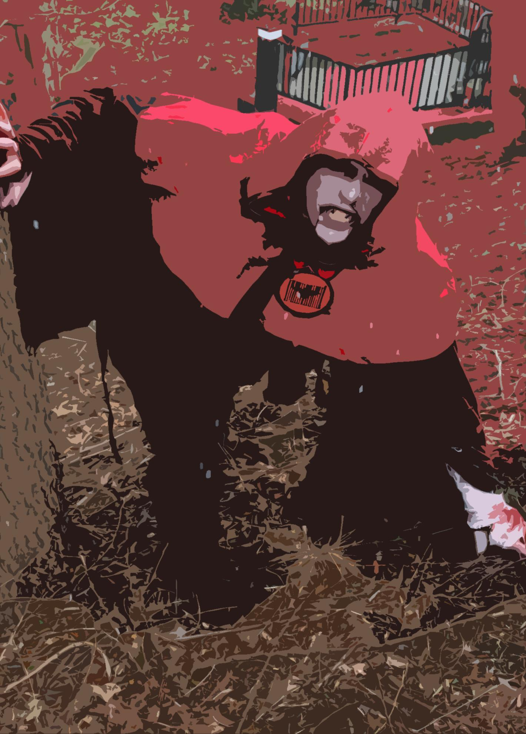

MIDDLEHAVEN

Oct. 18th-20th

The Next Big Long Island based Live Action Roll Playing game!
Come be a Hero…or not. Enslave the Princess and or destroy Evil!
Medieval fantasy based LARP!

Contact info for Character creation:
Conrad - 631 379 3305
cschnake@suffolk.lib.ny.us

Location:
Dorothy P. Flint 4-H Camp
3186 Sound Avenue
Riverhead, New York 11901

Cost:
Returning PC Players - $45.00
New PC Players- $20.00
Returning EMT Players (with equipment): $23.00
NPC Players- FREE
Saturday Dinner, Saturday and Sunday continental breakfast: $10 (PCs and NPCs)
REGISTRATION PAGE: https://sites.google.com/site/middlehaven/

DIRECTIONS TO CAMP:
Take the LIE to Exit 71 (Hampton Bays/Calverton). Turn left at bottom of exit ramp, cross the railroad tracks through light at Route 25 and continue north until you reach traffic light at Sound Avenue (approximately 3.9 miles from LIE to Sound Avenue). At traffic light turn right and continue east for 2.5 miles until you see the 4-H Camp sign at the West Entrance on the left side of the road. Turn left at the sign. Continue to drive into camp and park in the designated visitor parking.

