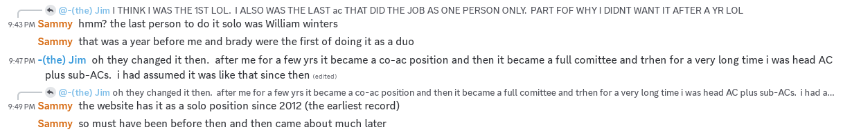
[9:42 PM]-(the) Jim: I THINK I WAS THE 1ST LOL. I ALSO WAS THE LAST ac THAT DID THE JOB AS ONE PERSON ONLY. PART FOF WHY I DIDNT WANT IT AFTER A YR LOL
[9:42 PM]-(the) Jim: bah silly caps lock
[9:43 PM]Sammy: hmm? the last person to do it solo was William winters
[9:44 PM]Sammy: that was a year before me and brady were the first of doing it as a duo
[9:47 PM]-(the) Jim: oh they changed it then. after me for a few yrs it became a co-ac position and then it became a full comittee and trhen for a very long time i was head AC plus sub-ACs. i had assumed it was like that since then (edited)
[9:49 PM]Sammy: the website has it as a solo position since 2012 (the earliest record)
[9:50 PM]Sammy: so must have been before then and then came about much later

