Meeting Notes February 12, 2020 Start: 1:05 PM

Tabs: Welcome to everyone who decided to come back 2 weeks in a row. I’m the president, Tabitha Chang, although I don’t think there are any new folks this time. Hello!

(RJ: [redacted])

(Rahib: ban time)

Ryan: Sorry, we started late, it’s my fault. Don’t touch expensive stuff all right? I didn’t explain it last week, but my job is internal affairs. Take that as you will.

Nate: Please take my job.

Angela: …

Tabs: very talkative this meeting

Jolee: There’s nothing to say. Please take out books.

Ken: So uh, a few things. I want to let you know that we have to pick the masquerade theme by the end of this meeting. [redacted about chicken little] I’m not saying it’s official, but I would like to see more sonic content on the 14th. If you’re feeling lonely on Valentine’s Day remember that Chicken Little is [redacted]. [redacted] [redacted]

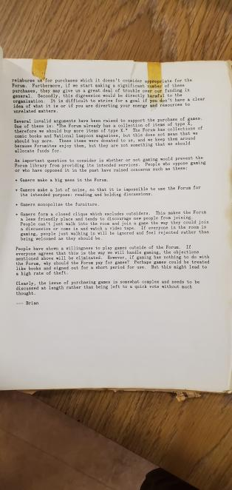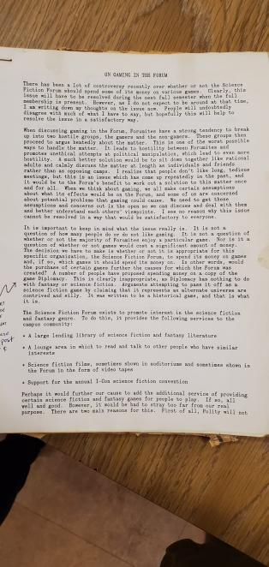Tabitha: I will be the substitute historian:

(I’m not typing this all out)

(Rahib: \*writes RIP Angela on his laptop as Tabs is reading all of this\*)

(David: That was longer than the rest of the meeting)

Tabs: By the way, we did end up getting Diplomacy. It’s in storage right now.

(RJ: I would like to state that when I looked left, I saw David with a look of shock on his face)

[redacted commotion about forumites past and their habits with ranting]

Hat made: $3.69

Jolee: Join PR Committee, and I also want to start a count on the board for who is interested in our knitting event for Baby Yoda.

Allocations:

Can't Catch Harry - TheOdd1'sOut Board Game -> $25.00

Batman: The Long Halloween -> $17.89

All-Star Superman -> $19.29

Blackest Night -> $19.99

Total = $82.17

Announcements:

Neville: I’m not left handed so my name looks like crap on attendance.

Nate: I won’t be there tomorrow for Chicken Little. It scarred me as a child.

Tabs: Old business, clean don’t be a dick. Treat this sofa like a child you don’t abuse. New business clean don’t be a dick. Treat this sofa like a child you don’t abuse.

Meeting ends: 1:17 PM