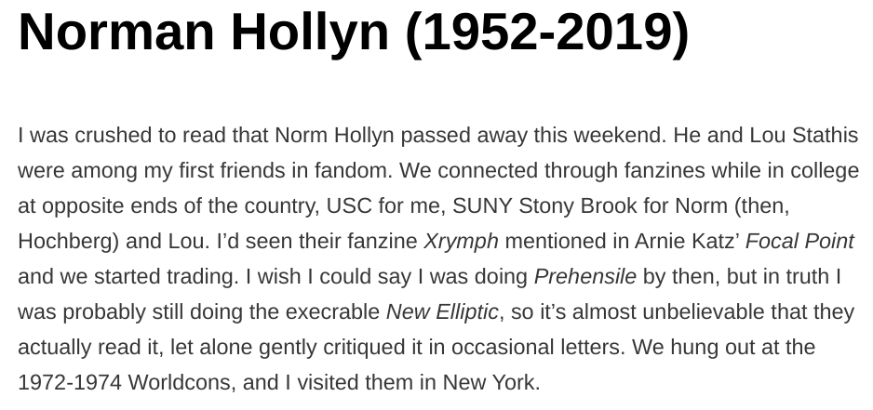
Note: Norman Hollyn was named Norm Hochberg according to Mike Dwyer’s 2019-03-19 retrospective upon his death (“https://file770.com/norman-hollyn-1952-2019/”)

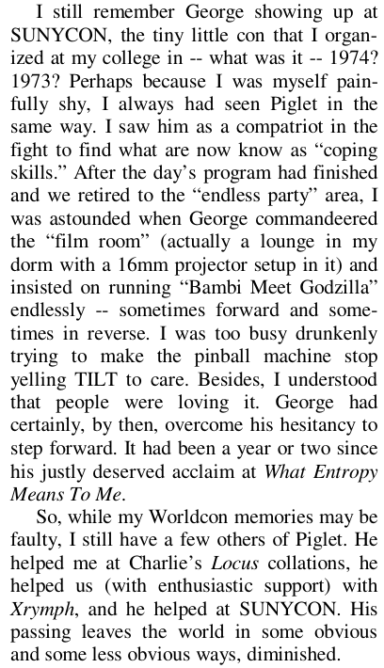
Article from File 770 #142 June 2003, page 18 (local source)

