Moving Status | [Oct. 25th, 2009|10:37 pm]
This is your presarian here!
Things are ridiculous.
The Champions:
David – who was my Gandalf & peeps to an overnight struggle at Helm’s Deep.
Adel (spelling?)
Peter
Dan
Everyone who showed up was very helpful.
The good news is that we managed to shift and crunch and de-box books so well together that we have acquired 1X: Computer Desk Space + Chair.
I sat in that chair for about three minutes, feeling totally BOSS.
I IMed Aaron briefly, and he told me that he’s going to set up the computer sometime Monday or Tuesday – and then next week install that secret bomber catalogue he has been prepping up for the forum (i.e. the one we bragged about during the 40th), but for now:
ResourceMate is going to try to hustle us for a subscription fee -- $75. I’m not paying for it, especially when its projected use will be about a week. So there was some talk about using the old catalogue system, Readerware while using the catalogue and cards for checking in-and-out books. I’m not sure when Aaron is going to be there, but any old shiftholders from last year should remember the drill if someone wants to check out something – and if they don’t, feel free to contact me.
I’m very pumped about running back to normal.
As for the moving situation, we did not really get a heavy amount of shiftshifting done, but I think we were moving around J-K to their edge. People should continue in reverse-alphabetical order if they feel up to the task, and then shelve ONLY MAIN STACKS. I tried to make it easy by having the authors who fit into the early alphabet on the front of the huge bookpile up.
So if you’re shelving, focus on that.
Here’s a MSPaint map of the forum, so you can get a better idea of what's going on: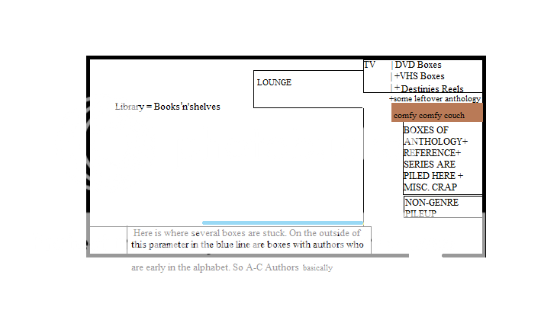

sekar_pryors

EDIT: We may still need some shelves for the forum. If anyone is interesting in hooking us with a good deal, forward me the details and I'll see what can be done. Thanks so much. =)
DOUBLE EDIT: We do have some additional shelves from Harriman Hall saved over, as Phil said, and they will help. I'm still am unsure if they'll take up all the space as needed, but I think they'll perform wonderfully in the ideal perfect futureForum.

