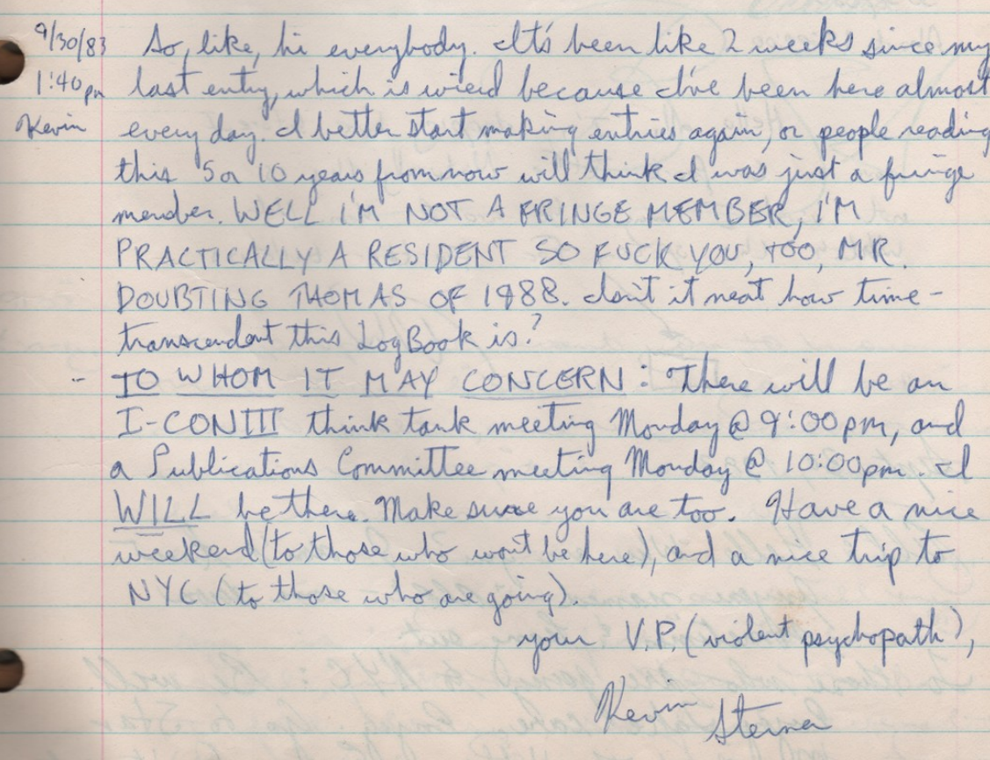
“So, like, hi everybody. It's been like 2 weeks since my last entry, which is weird because I've been here almost every day. I better start making entries again, or people reading this 5 or 10 years from now will think I was just a fringe member. WELL I'M NOT A FRINGE MEMBER, I'M PRACTICALLY A RESIDENT SO FUCK YOU, TOO, MR DOUBTING THOMAS OF 1988. Isn't it neat how time-transcendent this log book is?
TO WHOM IT MAY CONCERN: there will be an I-CON III think tank meeting Monday at 9:00 pm, and a Publications Committee meeting Monday at 10:00 pm. I will be there. Make sure you are too. Have a nice weekend (to those who won't be here), and a nice trip to NYC (to those who are going).
your V.P. (violent psychopath).
Kevin Sterner”

(from Log 23, 1983-09-30)

