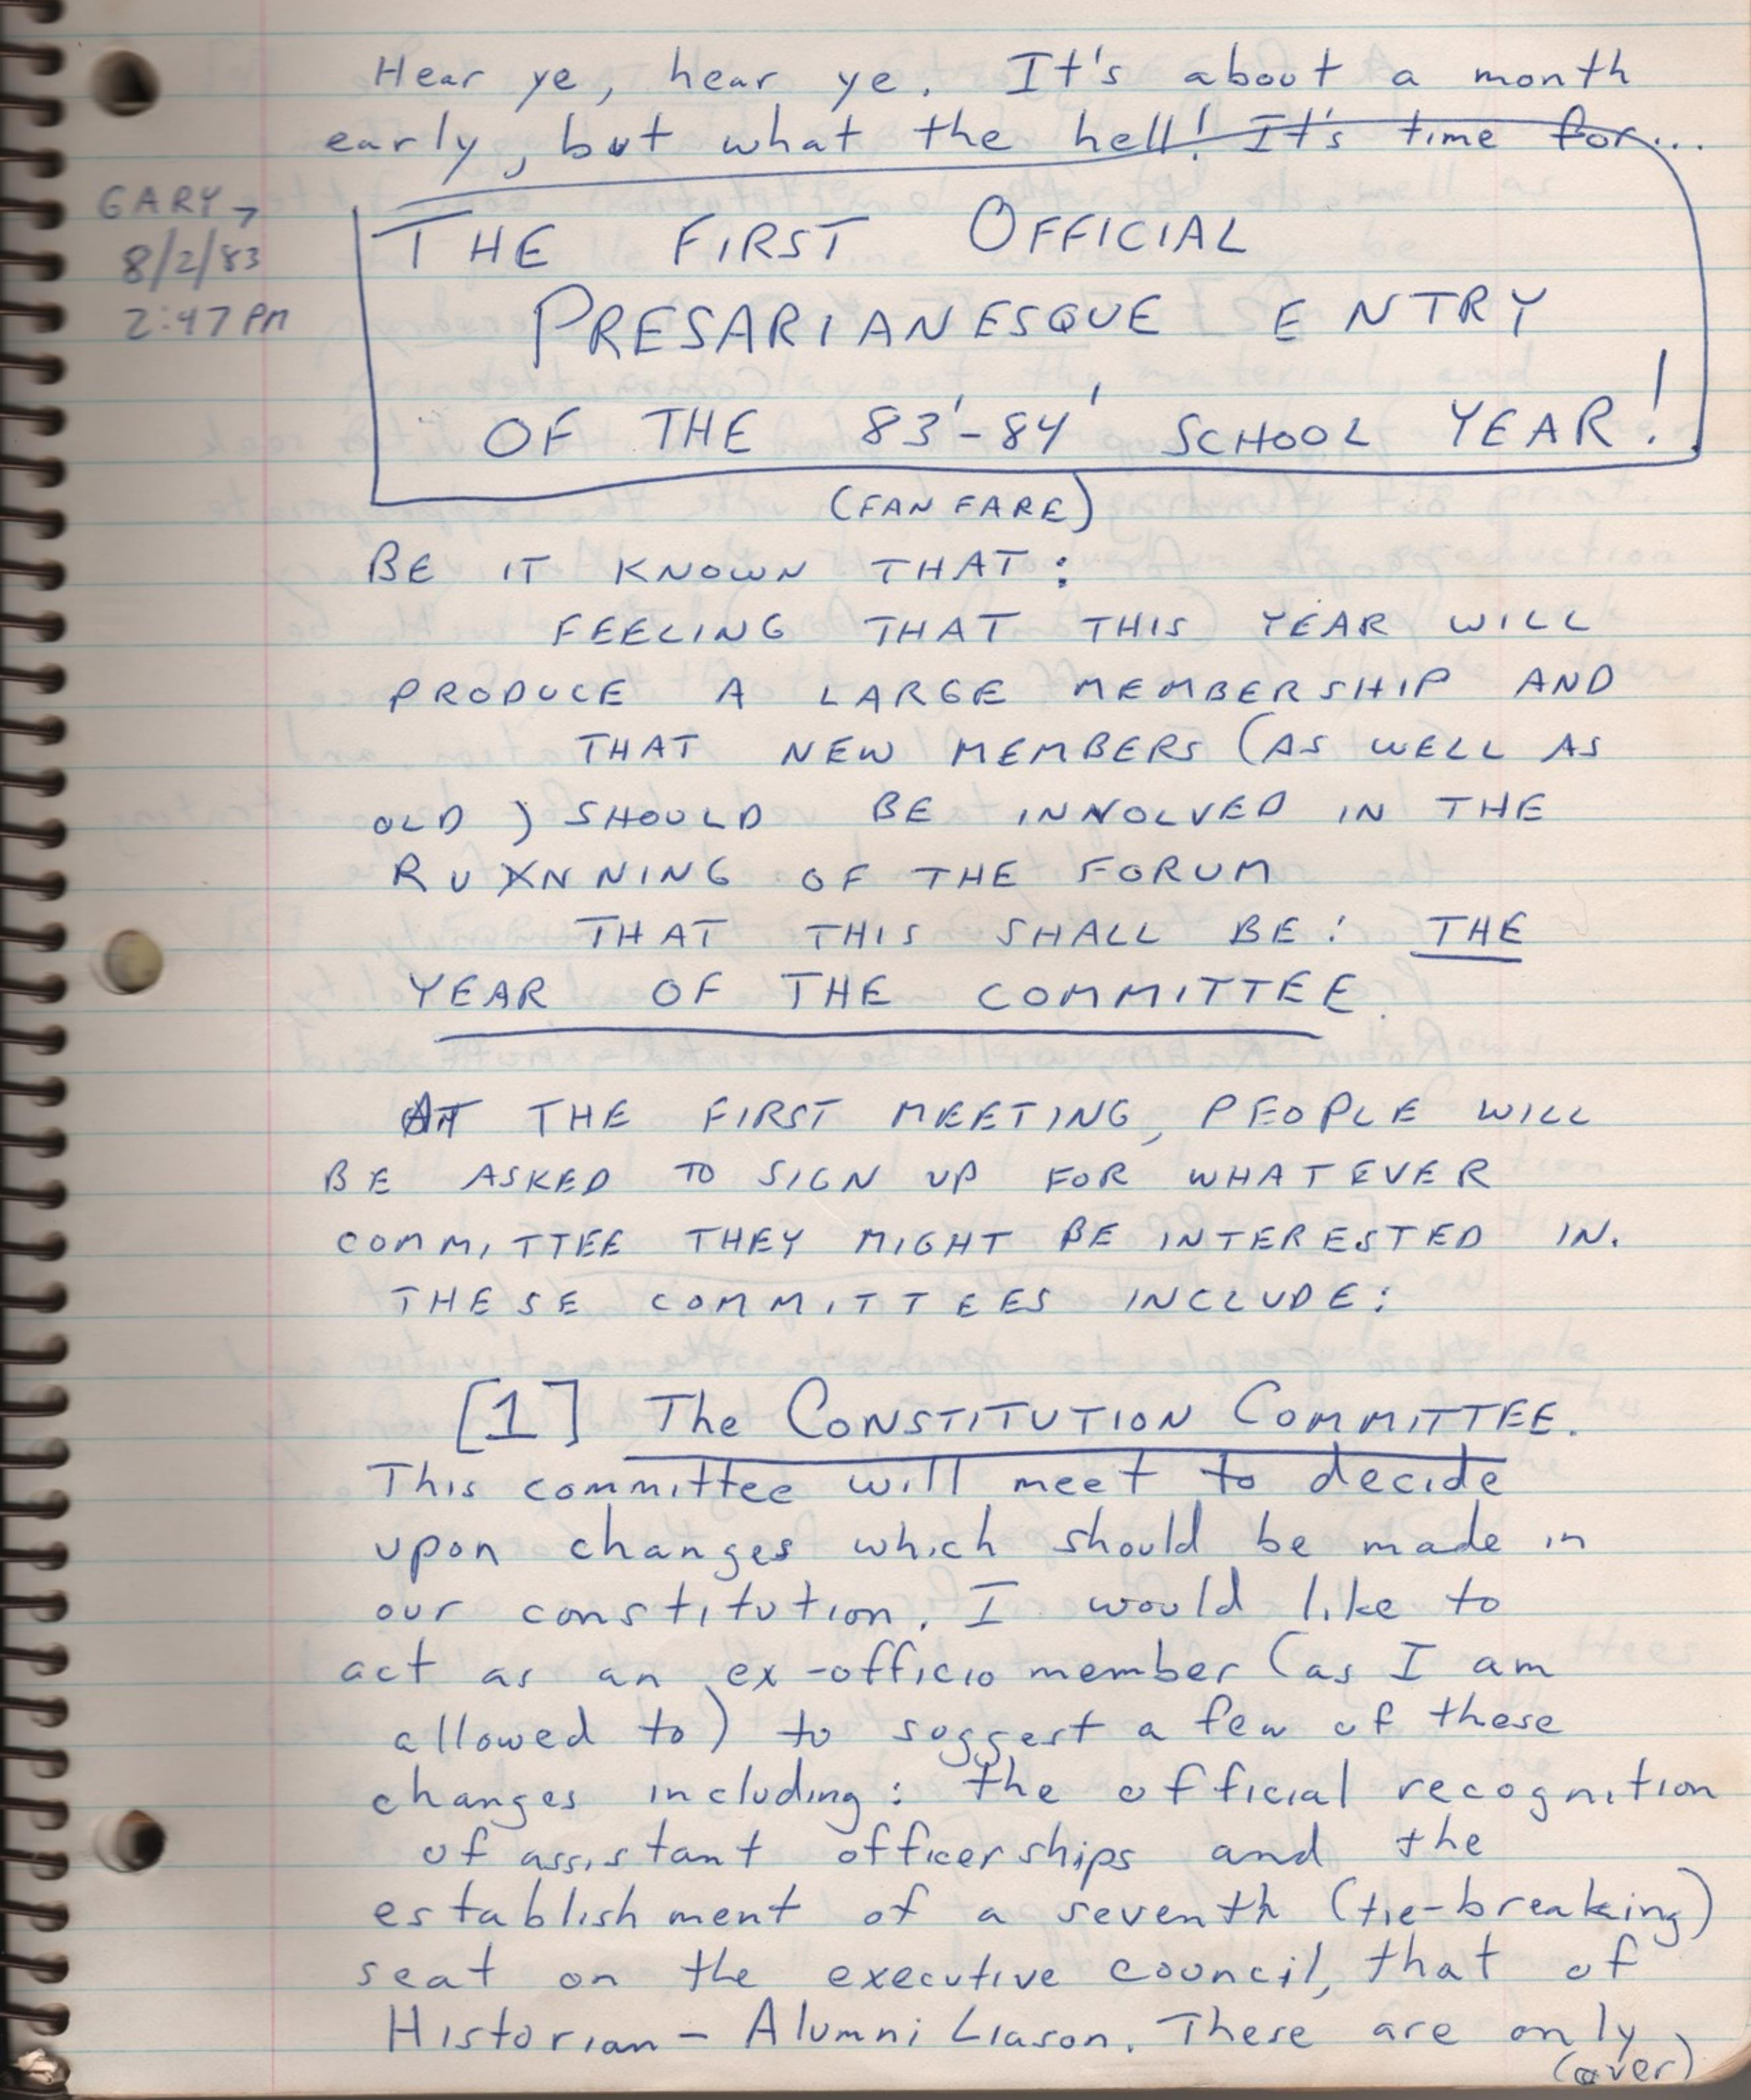

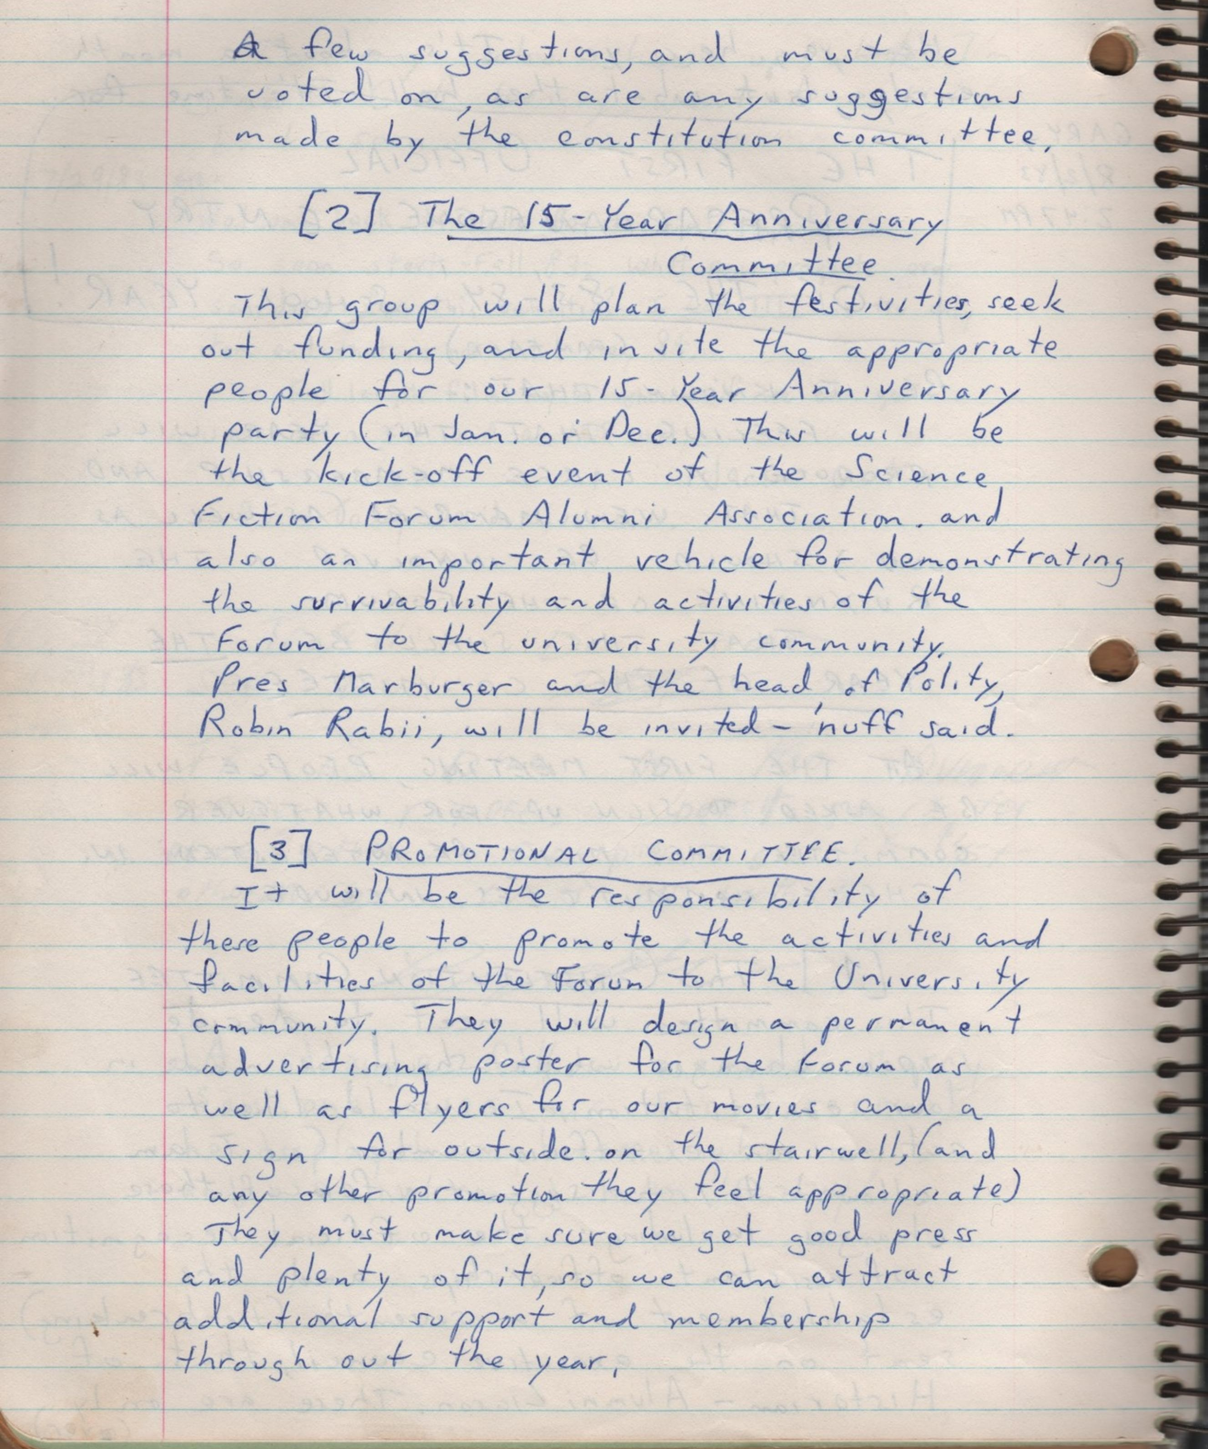

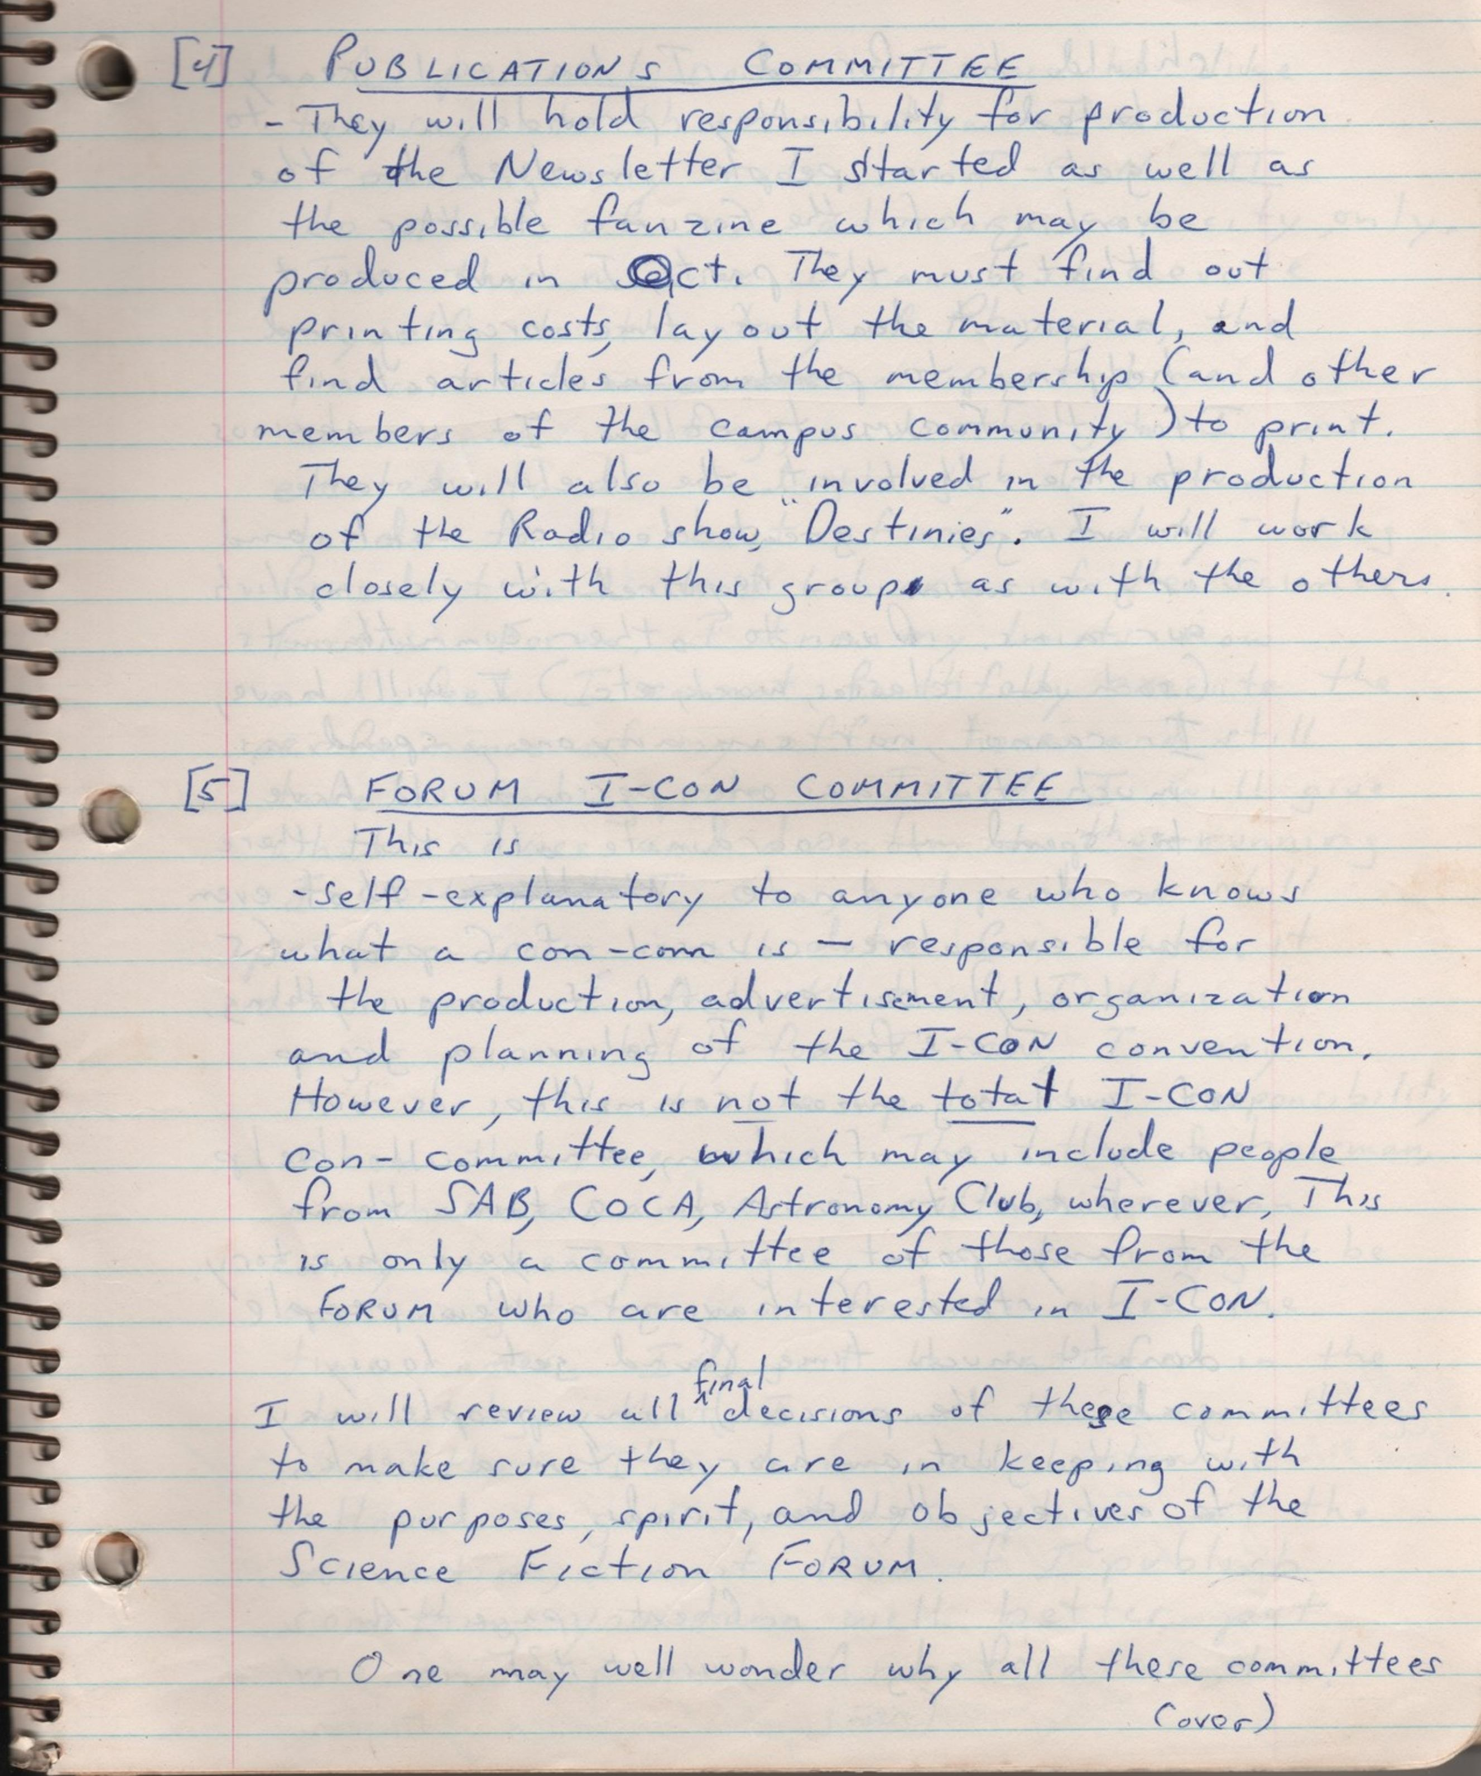

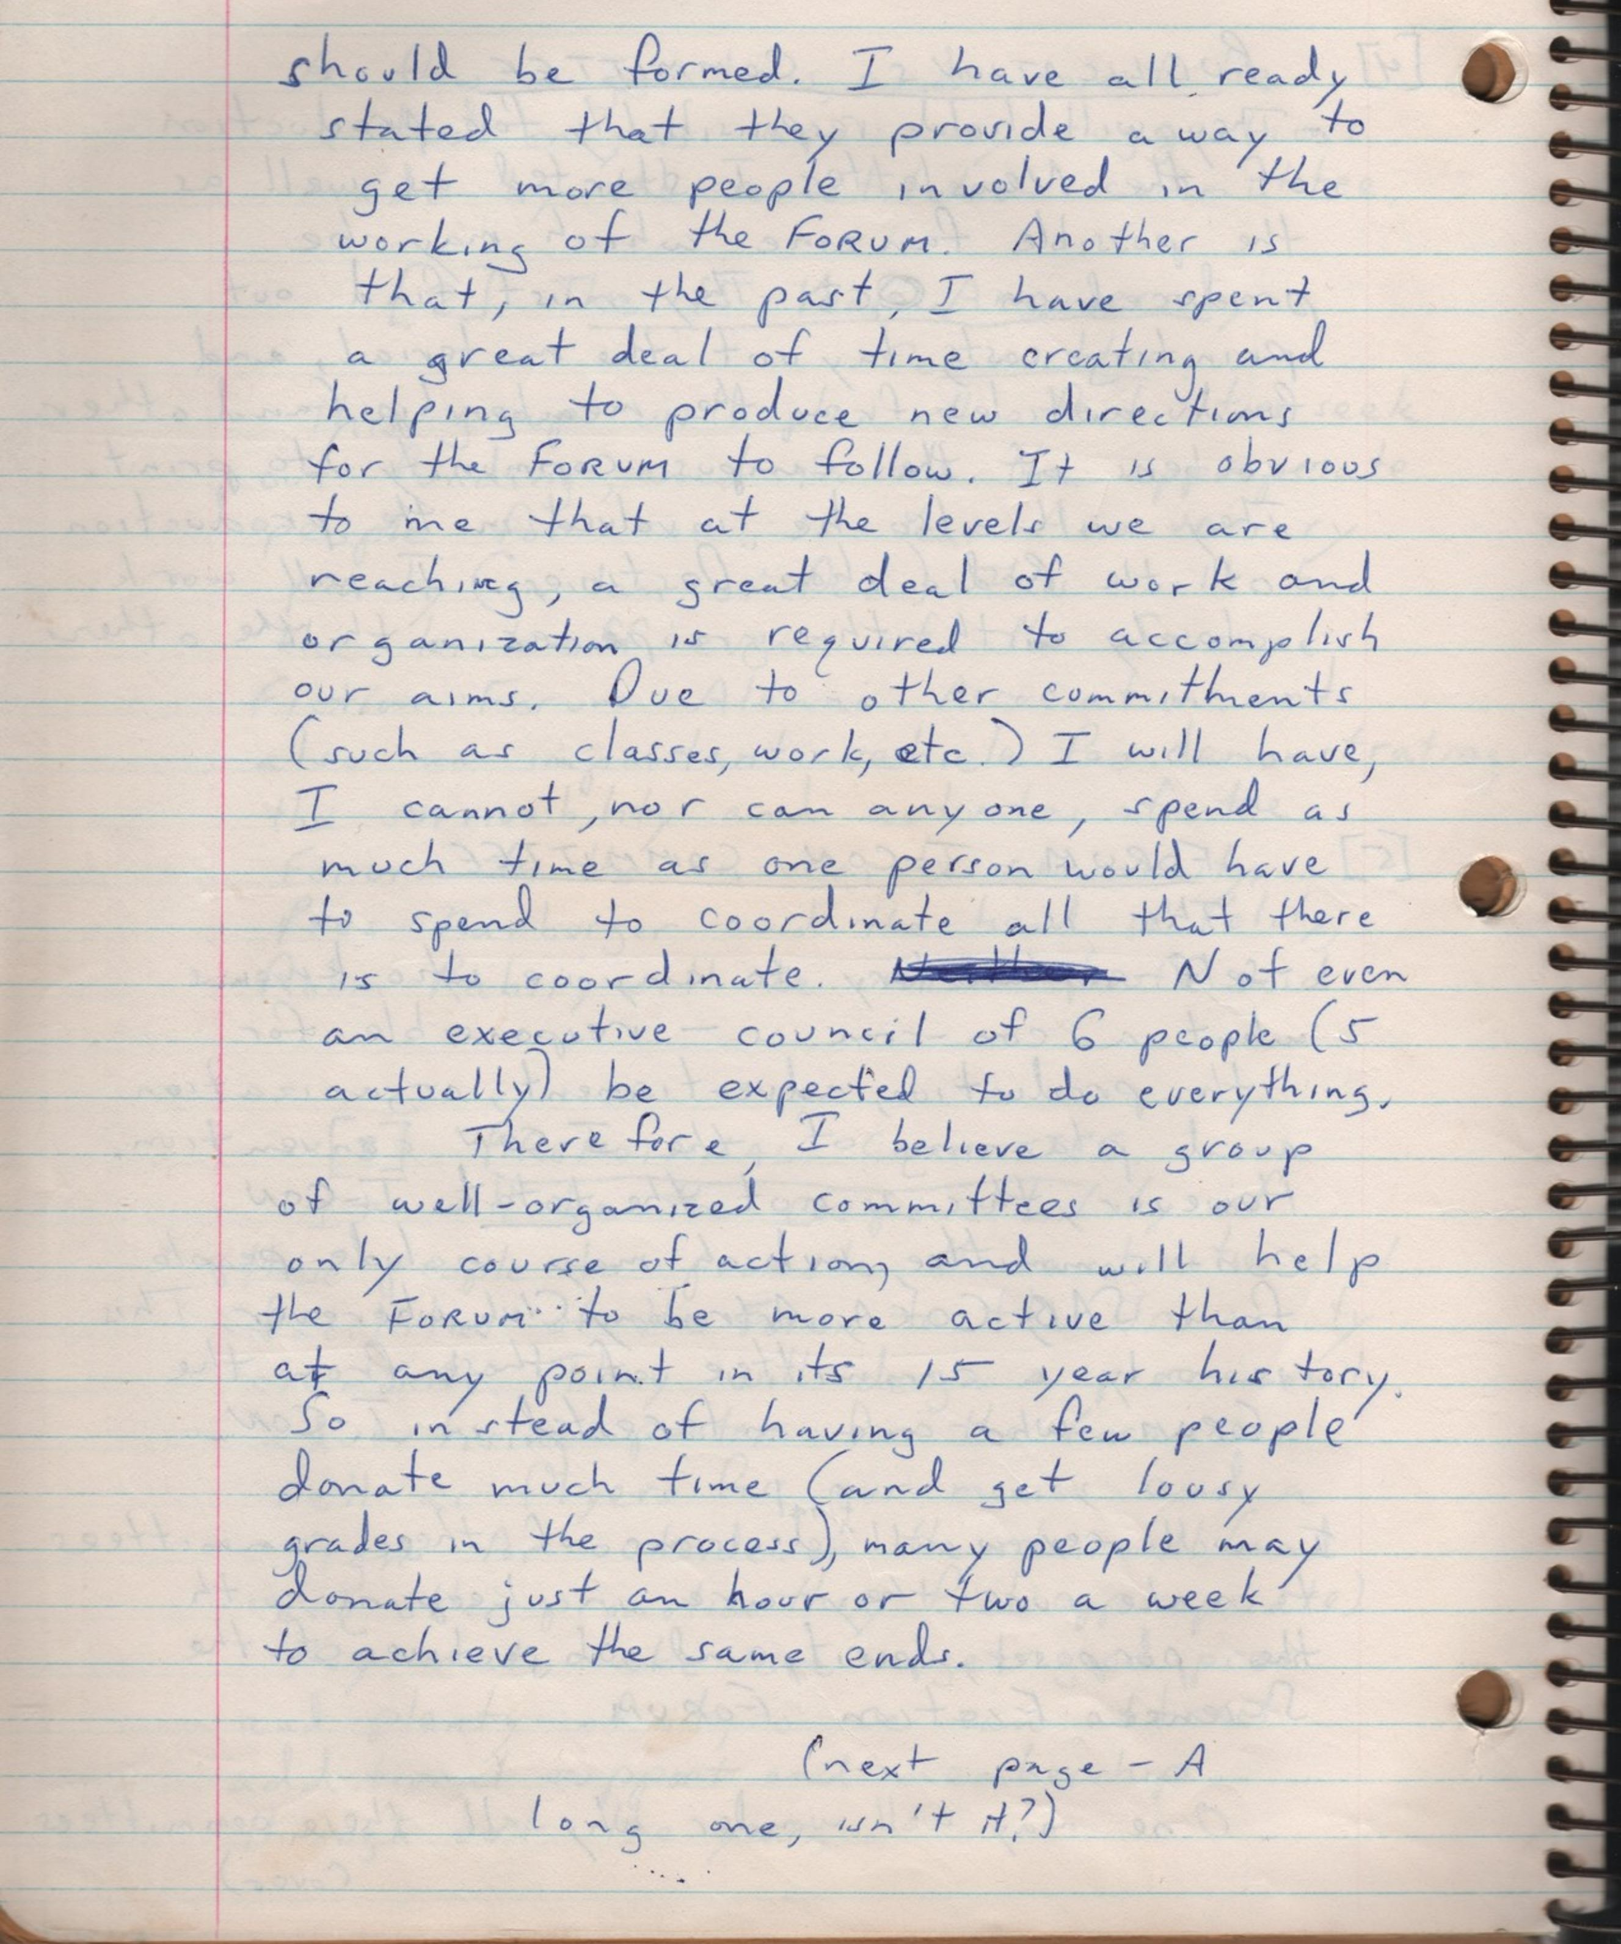
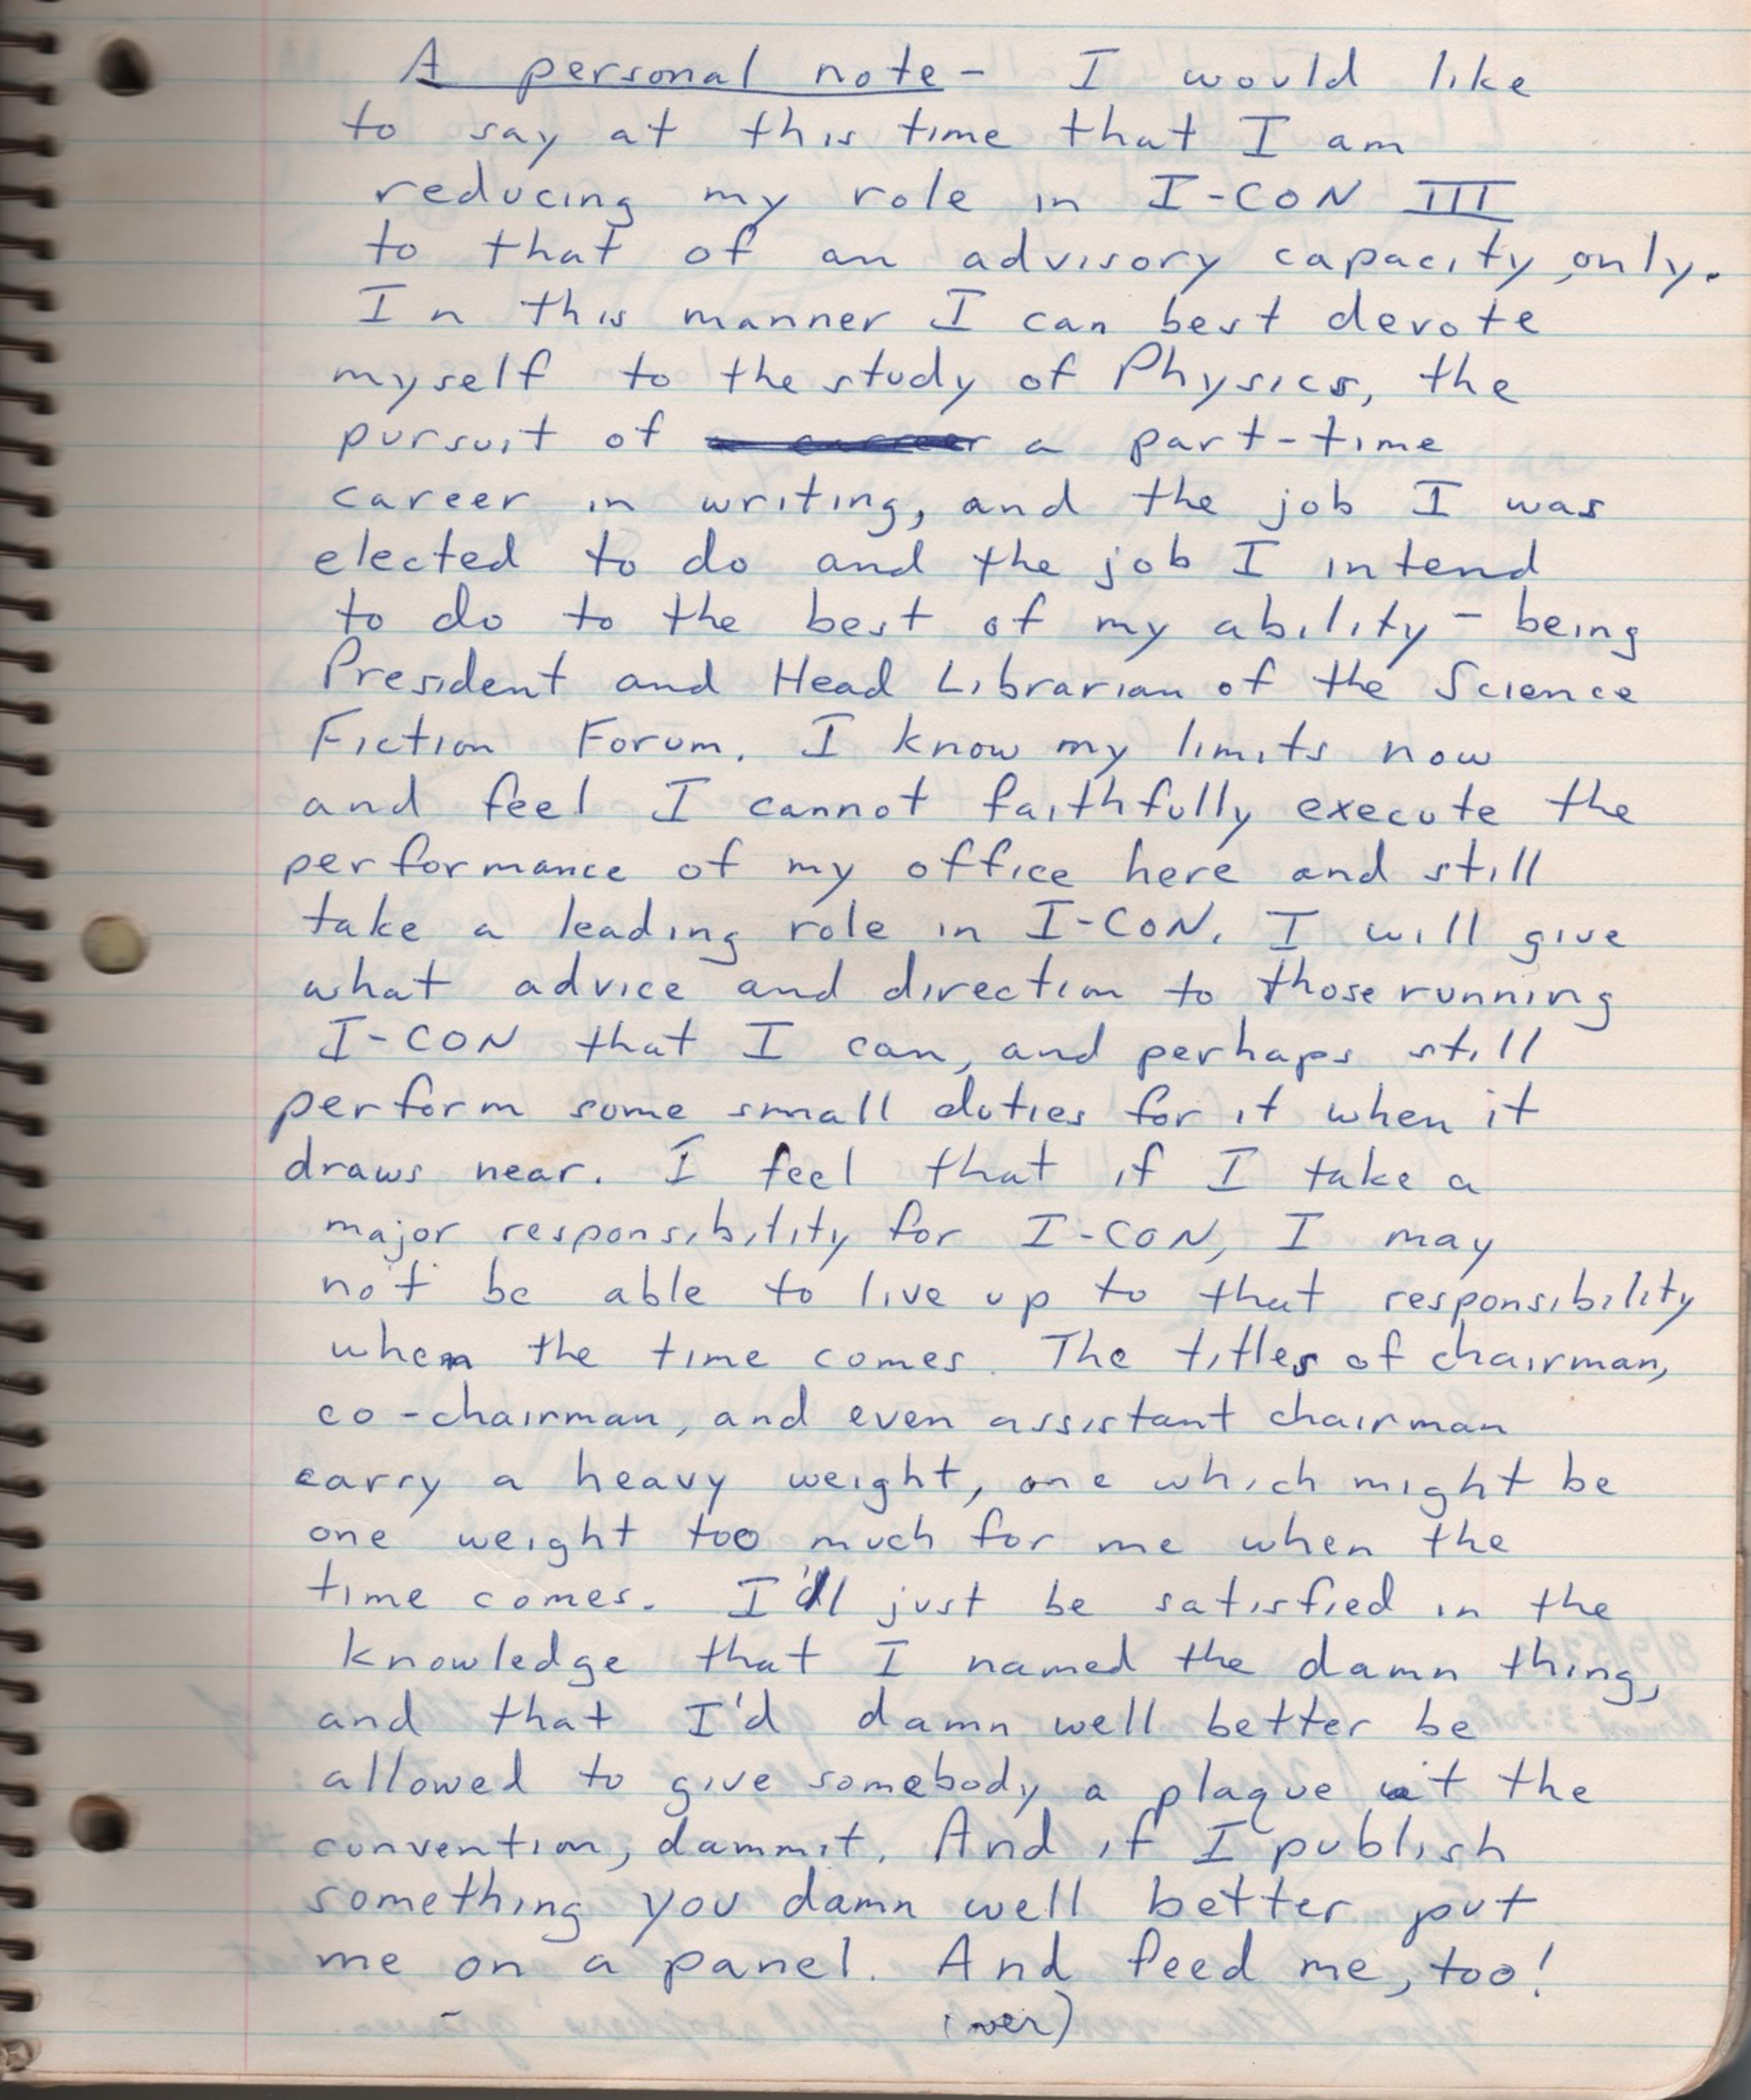

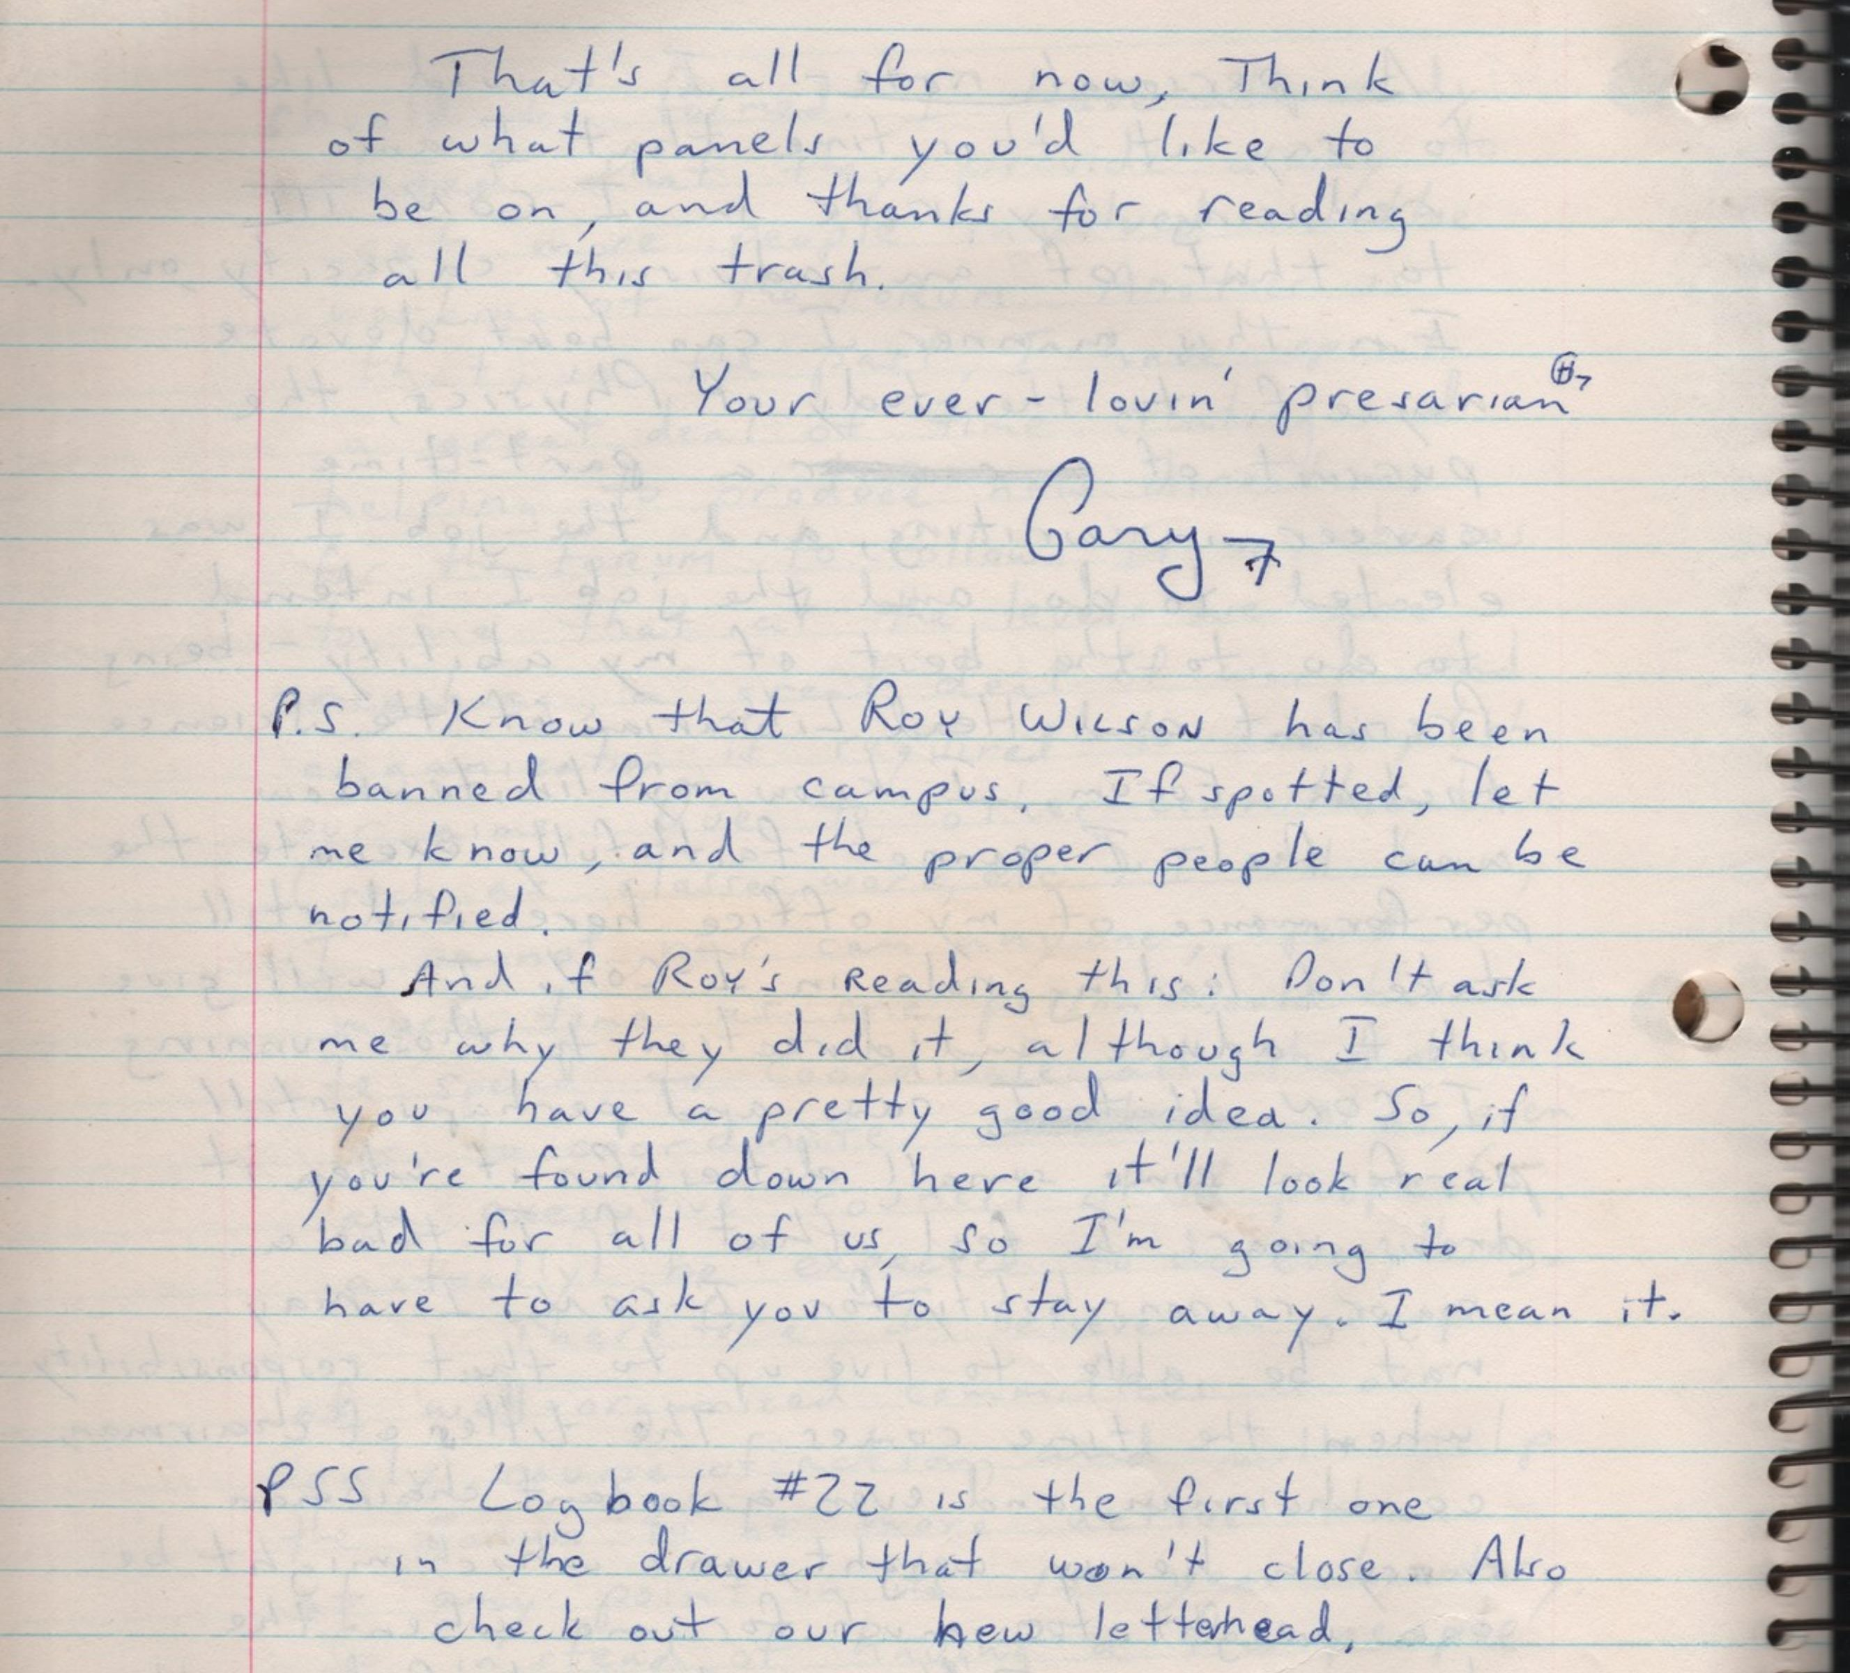
(partial transcript)

[4] PUBLICATIONS COMMITTEE
- They will hold responsibility for production of the newsletter I started as well as the possible fanzine which may be produced in Oct. They must find out printing costs, layout the material, and find articles from the membership (and other members of the Campus Community) to print. They will also be involved in the production of the radio show, "Destinies". I will work closely with this group as with the others.
[5] FORUM ICON COMMITTEE
This is
-self-explanatory to anyone who knows what a con-com is - responsible for the production, advertisement, organization and planning of the I-CON convention. However, this is not the total I-CON con committee, which may include people from SAB, COCA, Astronomy Club, wherever. This is only a committee of those from The Forum who are interested in icon.

(from Log 23, 1983-08-02)

