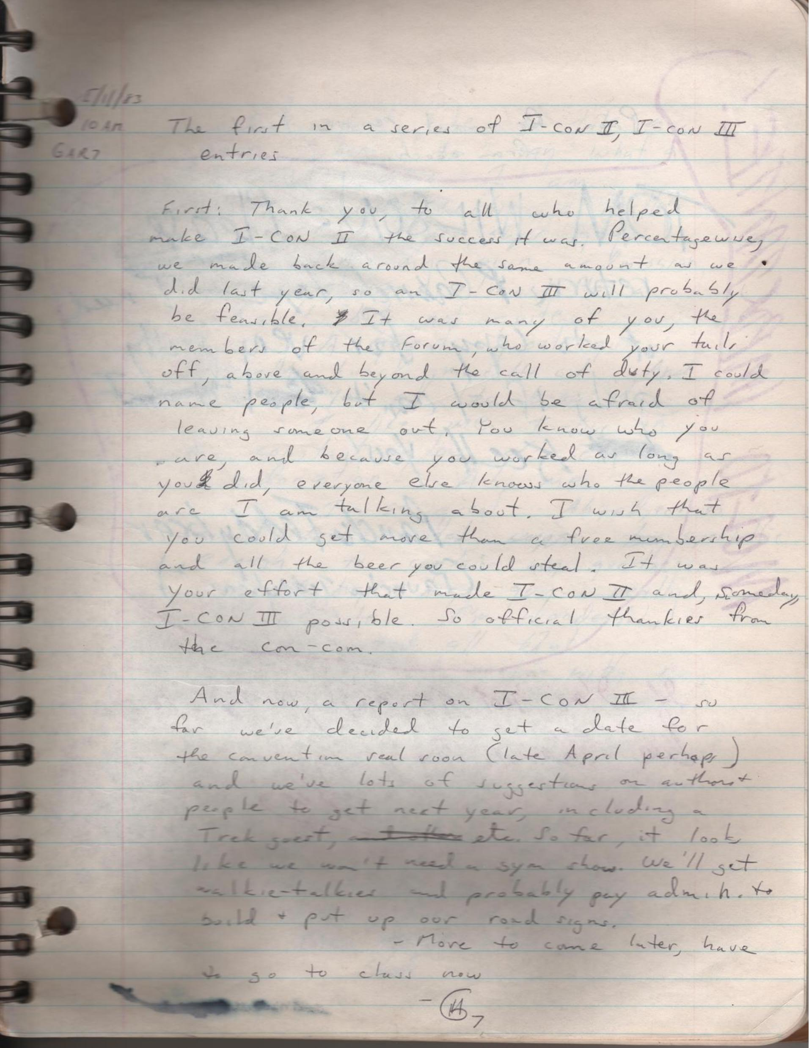

The first in a series of I-CON II, I-CON III entries.
First: Thank you, to all who helped make I-CON II be success it was. Percentage-wise, we made back around the same amount as we did last year, so an I-CON III will probably be feasible. It was many of you, the members of the forum, who worked your tails off, above and beyond the call of duty. I could name people, but I would be afraid of leaving someone out. You know who you are, and because you worked as long as you did, everyone else knows who the people are I am talking about. I wish that you could get more than a free membership and all the beer you could steal. It was your effort that made I-CON and, someday, I-CON III possible. So official thank you from the con-com.
And now a report on I-CON III - so so far we've decided to set a date for the convention real soon ( late April perhaps ) and we've lots of suggestions on authors and people to get next year, including a trek guest, etc. So far, it looks like we won't need a SIM show. We'll get walkie talkies and probably pay admin to build and put up our road signs.
- More to come later, have to go to class now
-G7 [Gary “7” Halada]

(from Log 22, 1983-05-11)

