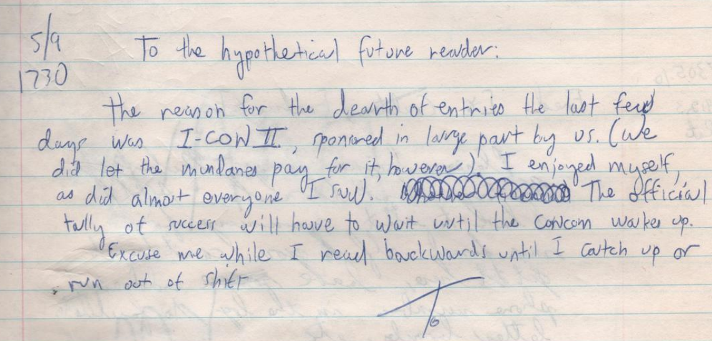
To the hypothetical future member:

the reason for the dearth of entries the last few days was I-CON II, sponsored in large part by us. (we did let the mundanes pay for it, however) I enjoyed myself, as did almost everyone I saw. The official tally of success will have to wait until the concom wakes up.
Excuse me while I read backwards until I catch up or run out of shift.

(from Log 22, 1983-05-09)

