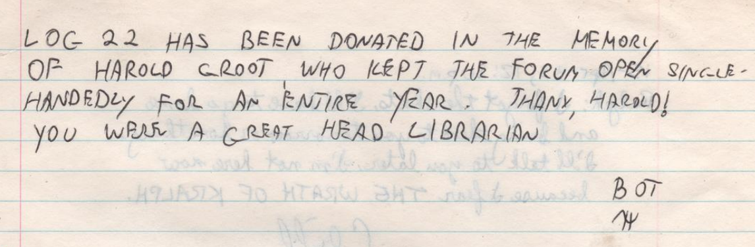
“Log 22 has been donated in the memor of Harold Groot, who kept the Forum open single-handedly for an entire year. Thanx, Harold! You were a great Head Librarian
BOT”

(from Log 22, 1983-04-14)

