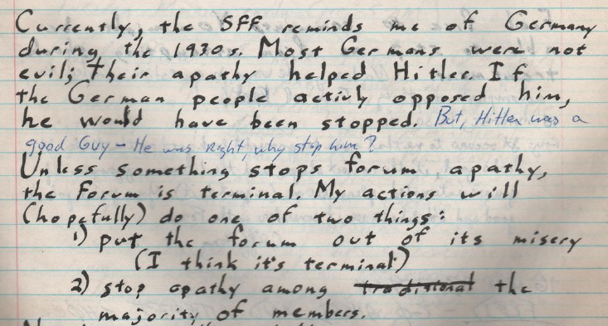
"Currently the SFF reminds me of Germany during the 1930s. Most Germans were not evil; there apathy helped Hitler"
-Fred, invoking Godwin's Law almost a decade before that was a thing

