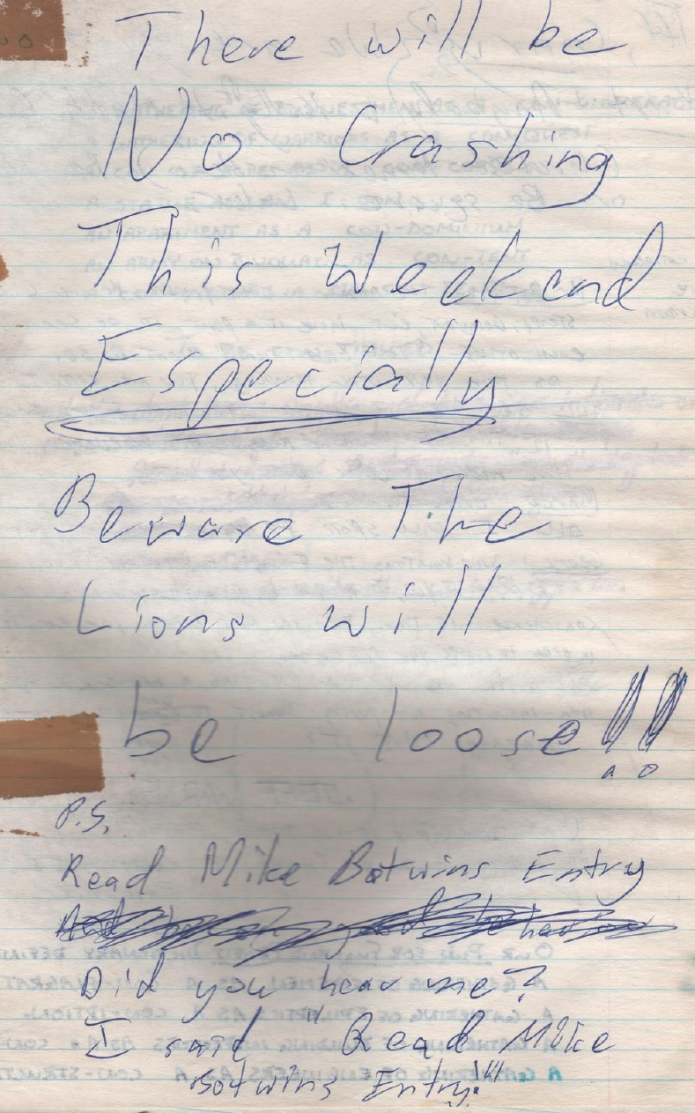
Warning to potential overnight sleeper in the Forum during the first I-CON
(from Log 17, 1982-03-10)

