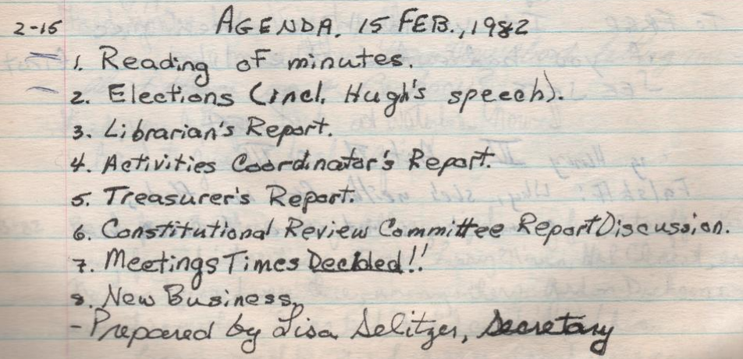
Agenda. 15 Feb 1982
1. Reading of inutes
2. Elections (incl. Hugh’s speech).
3. Librarian’s Report
4. Activities Coordinator’s Report.
5. Treasurer’s Report.
6. Constitutional Review Committee Report Discussion.
7. Meetings Times Decided!!
8. New Business
-Prepare by Lisa Selitzer, Secretary

