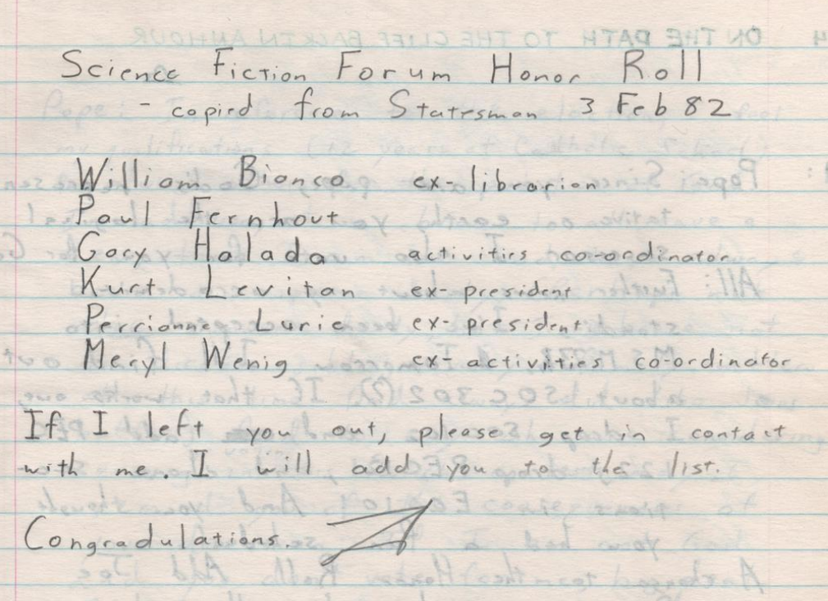
Science Fiction Forum Honor Roll
-copied from Statesman 3 Feb 82
William Bianco ex-librarian
Paul Fernhout
Gary Halada activities co-ordinator
Kurt Levitan ex-president
Perrianne Lurie ex-president
Meryl Wenig ex-activities co-ordinator

If I left you out, please get in contact with me. I will add you to the list
Congradulations (probably Fred Coulter’s signature, per 1982-02-04 post)

(from Log 17, 1982-02-03)

