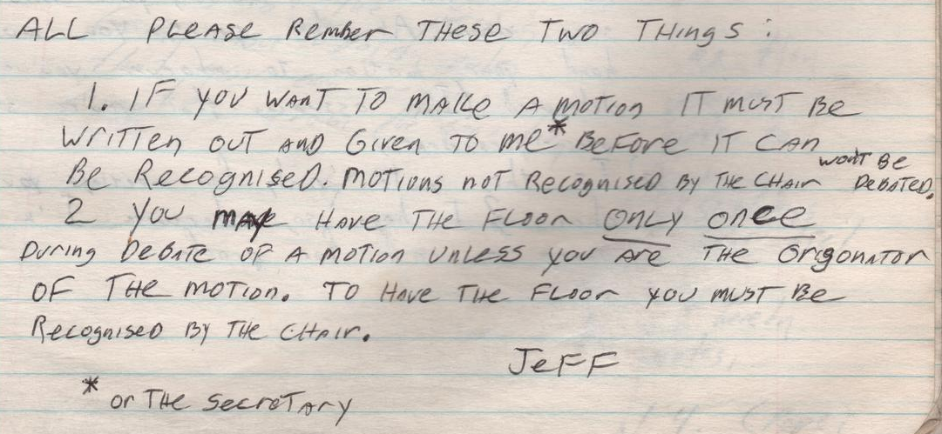
All Please rember these two things:

1. If you want to make a motion it must be written out and given to me* before it can be recognized. Motions not recogized by the chair won’t be debated.
2. You may have the floor only once during debate of a motion unless you are the origonator of the motion. To have the floor you must be recognized by the chair.
Jeff
* or the secretary

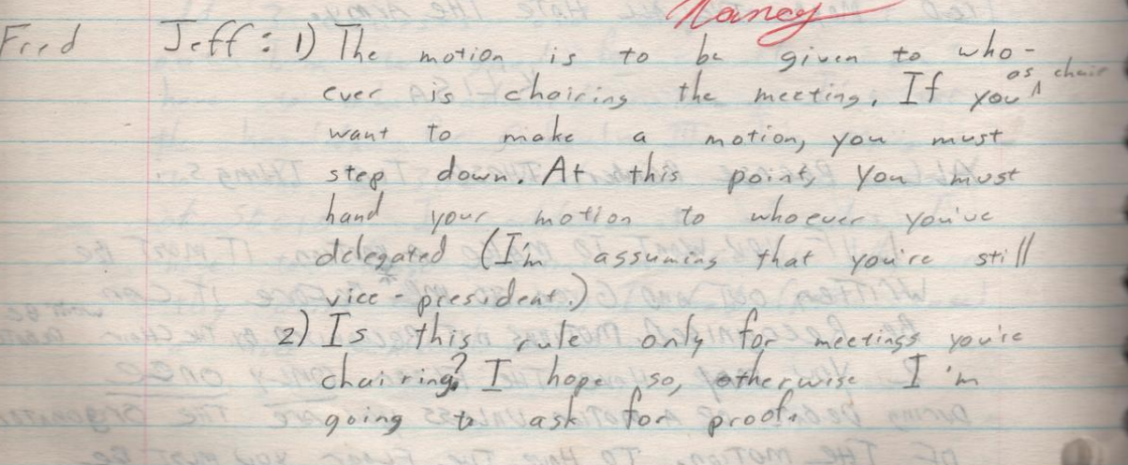
[from] Fred
Jeff: 1) The motion is to be given ot whoever is chairing the meeting, IF you as chair want to make a motion, you must step down. At this point, you must hand yourmotion to whoever you’ve delegated (I’m assuming that you’re still vice-president)
2) Is this rule only for meetings you’re chairing? I hope so, otherwise I’m going to ask for proof.

(from Log 17, 1982-02-02 and -03)

