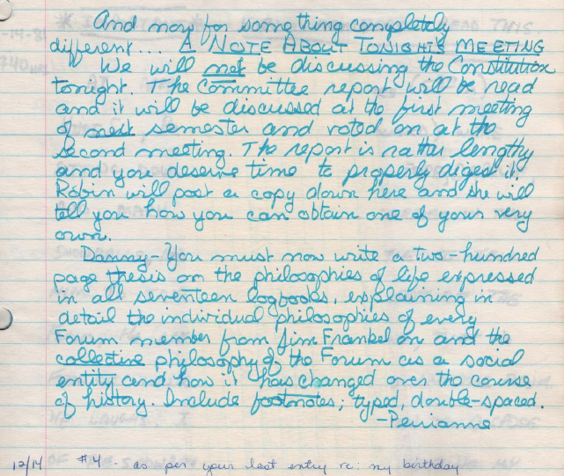
"A NOTE ABOUT TONIGHT'S MEETING
We will not be discussing the Constition tonight"
-Perrianne

(from Log 17, 1981-12-14)

