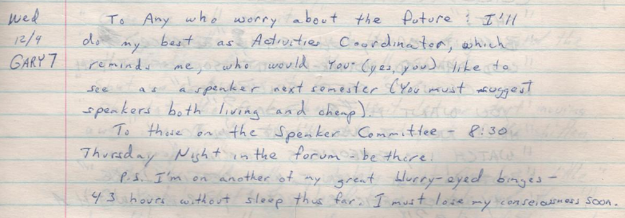
Wed
12/9
GARY7

"To Any who worry about the future: I'll do my best as Activities Coordinator"

(from Log 17, 1981/12/09)

