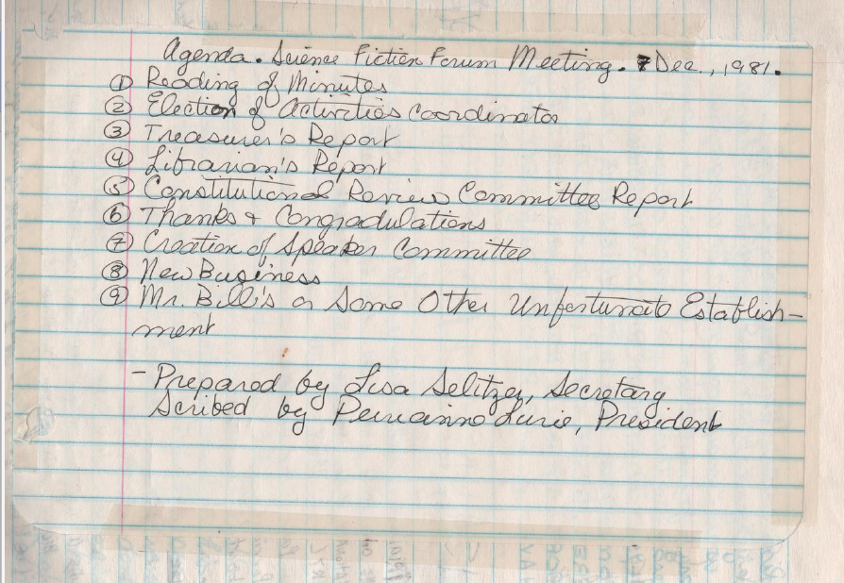
Agenda. Science Fiction Forum Meeting. 7 Dec, 1981.
(1) Reading of Minutes
(2) Election of Activities Coordinator
(3) Treasurer's Report
(4) Librarian's Report
(5) Constitutional Review Committee Report
(6) Thanks & Congratulations
(7) Creation of Speaker Committee
(8) New Business
(9) Mr. Bill's or Some other Unfortunate Establishment
- Prepared by Lisa Selitzer, Secretary
Scribed by Perianne Lurie, President

