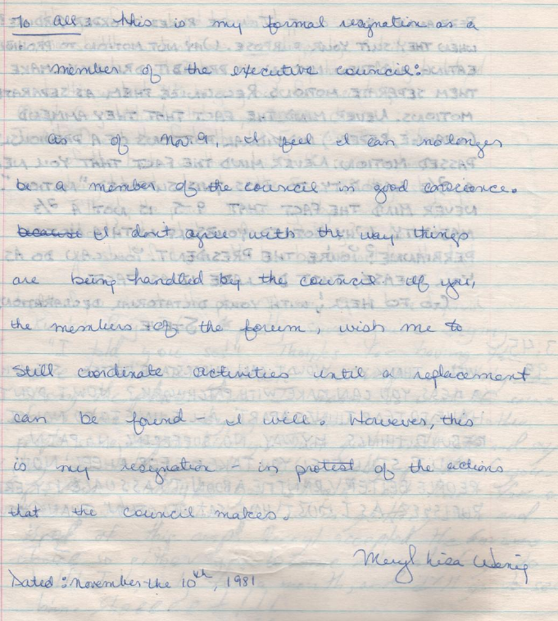
"this is my formal resignation as a member of the executive council…. If you, the members of the forum, wish me to still coordinate activities until a replacement can be found – I will. However, this is my resignation – in protest of the actions that the coincil makes.
Meryl Lisa(?) Wenig
Dated: November the 10th, 1981"

LOG 17

