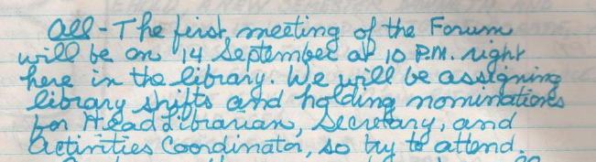
"All – The first meeting of the Forum will be on 14 September at 10 P.M. right here in the library. We will be assigning library shifts and holding nominations for Head Librarian, Secretary, and Activities Coordinator, so try to attend."
-Perianne Lurie, LOG 15, 1981-09-05

