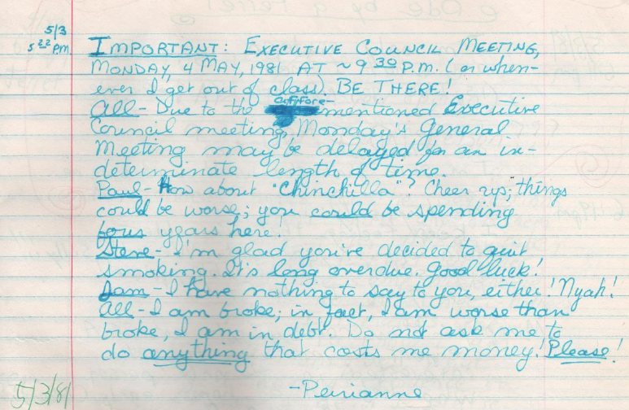
Important: Executive Council Meeting,
Monday, 4 May 1981 at ~9:30p.m. (or when-
ever I get out of class). BE THERE!
<unimportant stuff>
-Perianne [Lurie]

Source: Log 15, 1981-05-03

