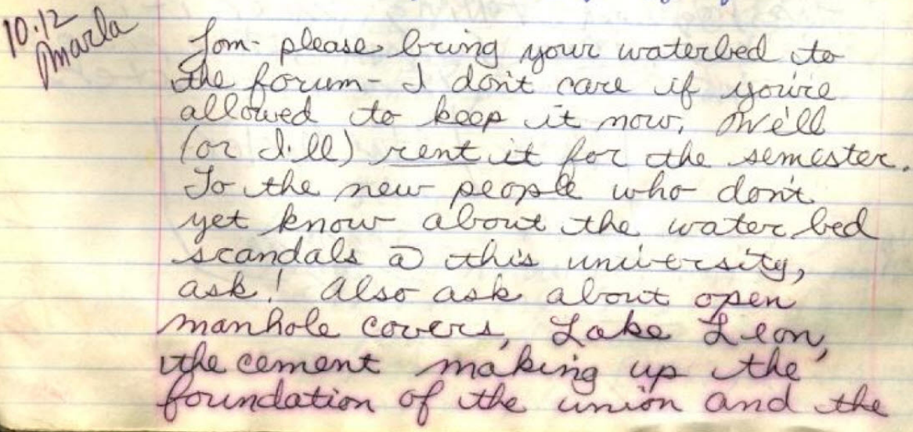
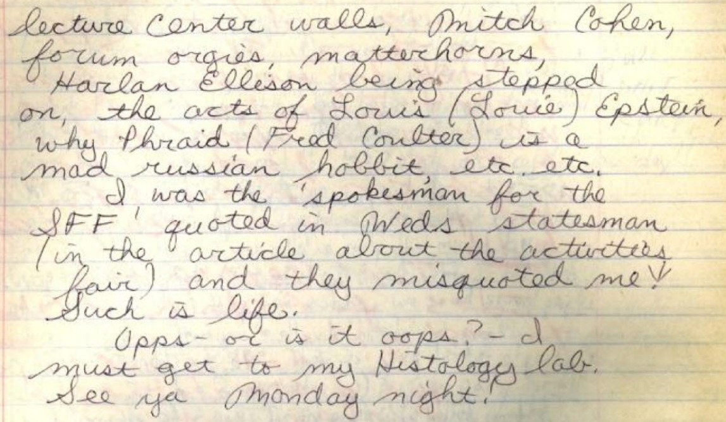
...please bring your waterbed to The Forum - I don't care if you're allowed to keep it now. We'll (or I'll) rent it for the semester. To the new people who don't yet know about the water bed scandals @ this university, ask! Also ask about open manhole covers, Lake Leon, the cement making up the foundation of the union and the lecture center walls, Mitch Cohen, forum orgies, matterhorns, Harlan Ellison being stepped on, the acts of Louis (Louie) Epstein, why Phraid (Fred Coulter) is a mad russian hobbit, etc. etc.
I was the 'spokesman for the SFF' quoted in Weds Statesman (in the article about the activities fair) and they misquoted me. Such is life
Opps - or is it oops? - I must get to my histology lab.
See ya Monday night!

(from Log 009 a, 1979-10-12)

