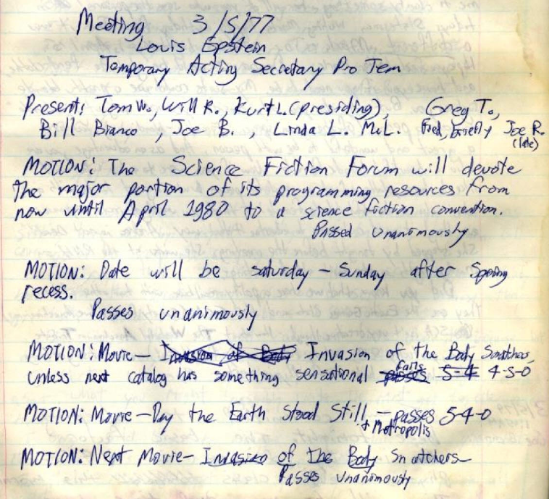
Meeting 3/5/77<sic>
Louis Epstein
Temporary Acting Secretary Pro Tem

Present: Tom W., Will R., Kurt L. (presiding), Greg T., Bill Bianco, Joe B., Linda L., M?L. Fred, briefly Joe R. (late)

MOTION: The Science Fiction Forum will devote the major portion of its programming resources from now until April 1980 to a science fiction convention.
Passed unanimously

MOTION: Date will be Saturday-Sunday after Spring recess
Passes unanimously

MOTION: Movie – Invasion of the Body Snatchers unless next catalog has something sensational passes 5-4-0 fails 4-5-0

MOTION: Movie – Day the Earth Stood Still & Metropolis – passes 5-4-0

MOTION: Next Movie – Invasion of the Body Snatchers – Passes unanimously

MOTION: Adjourn
Passes

(from Log 007 d, 1979-03-05)

