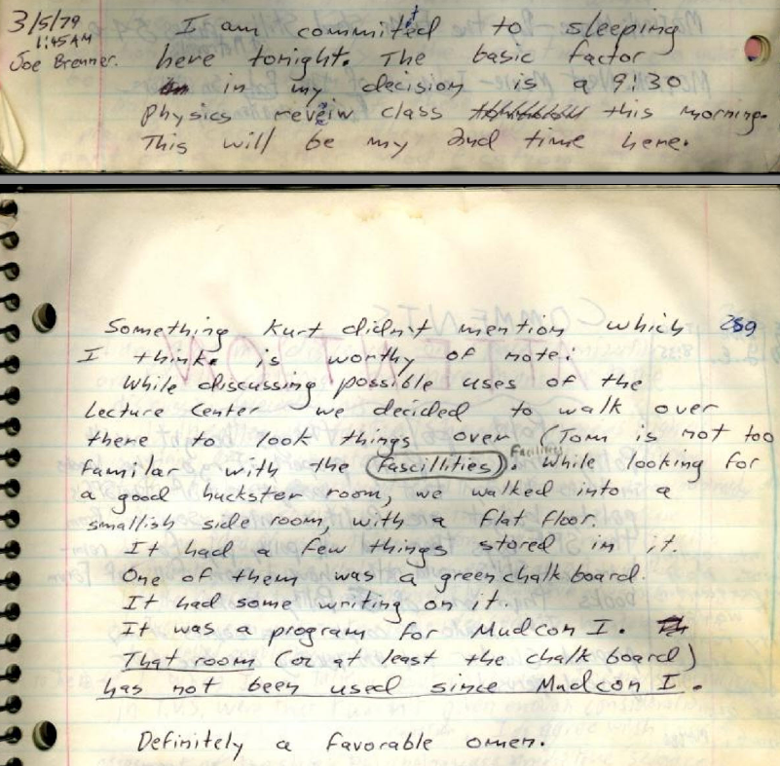
"While discussing possible uses of the Lecture Center we decided to walk over there to look things over (Tom is not too familiar with the fascillities<sic>. While looking for a good huckster room, er walked into a smallish side room, with a flat floor.
It had a few things stored in it.
One of them was a green chalk board.
It had some writing on it.
It was a program for Mudcon I.
That room (or at least the chalk board) has not been used since Mudcon I.

Definitely a favorable omen."
-Joe Brenner, 3/5/79 1:45am

(from Log 007 d, 1979-03-05)

