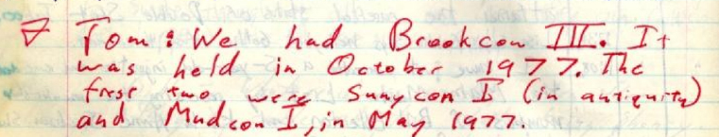
"Tom: We had Brookcon III. It was held in October 1977. The first two were Sunycon I (in antiquity) and Mudcon I, in May 1977."

(from Log 007 d, 1979-03-04)

