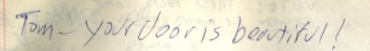
"Tom – your door is beautiful!"
-Greg, Log 007 b, 1978-12-07

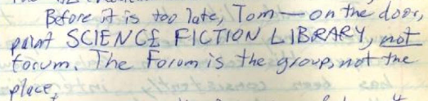
"Before it is too late, Tom – on the door, print SCIENCE FICTION LIBRARY, not forum. The Forum is the group, not the place."
-Louis Epstein, Log 007 b, 1978-12-10

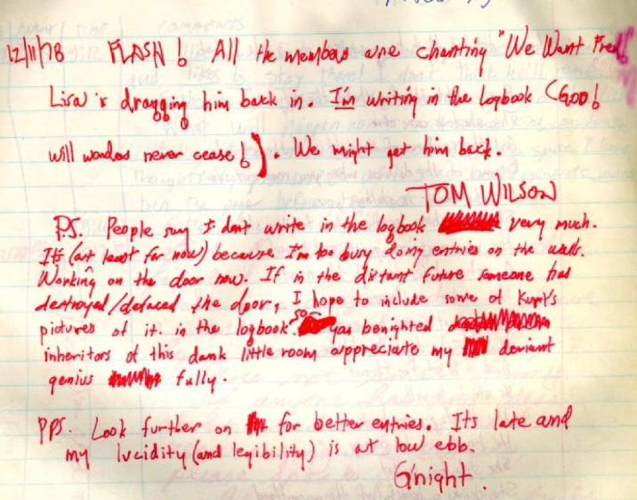
"Working on the door now. If in the distant future someone had destroyed/defaced the door, I hope to include some of Kurt's pictures of it in the logbook so you beknighted inheritors of this dank little room appreciate my deviant genius fully"
-Tom Wilson, Log 007 b, 1978-12-11

