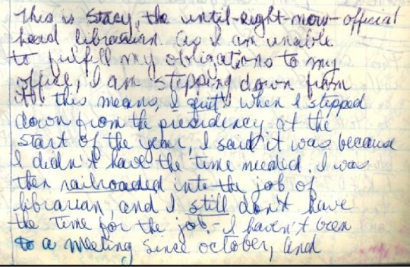
"This is Stacy, the until-right-now-official head librarian. As I am unable to fulfill my obligations to my office, I am stepping down from it. This means, I quit. When I stepped down from the presidency at the start of the year, I said it was because I didn’t have the time needed. I was then railroaded into the job of librarian, and I still don't have the time for the job. – I haven't been to a meeting since october..."

(from Log 007 a, 1978-11-20)

