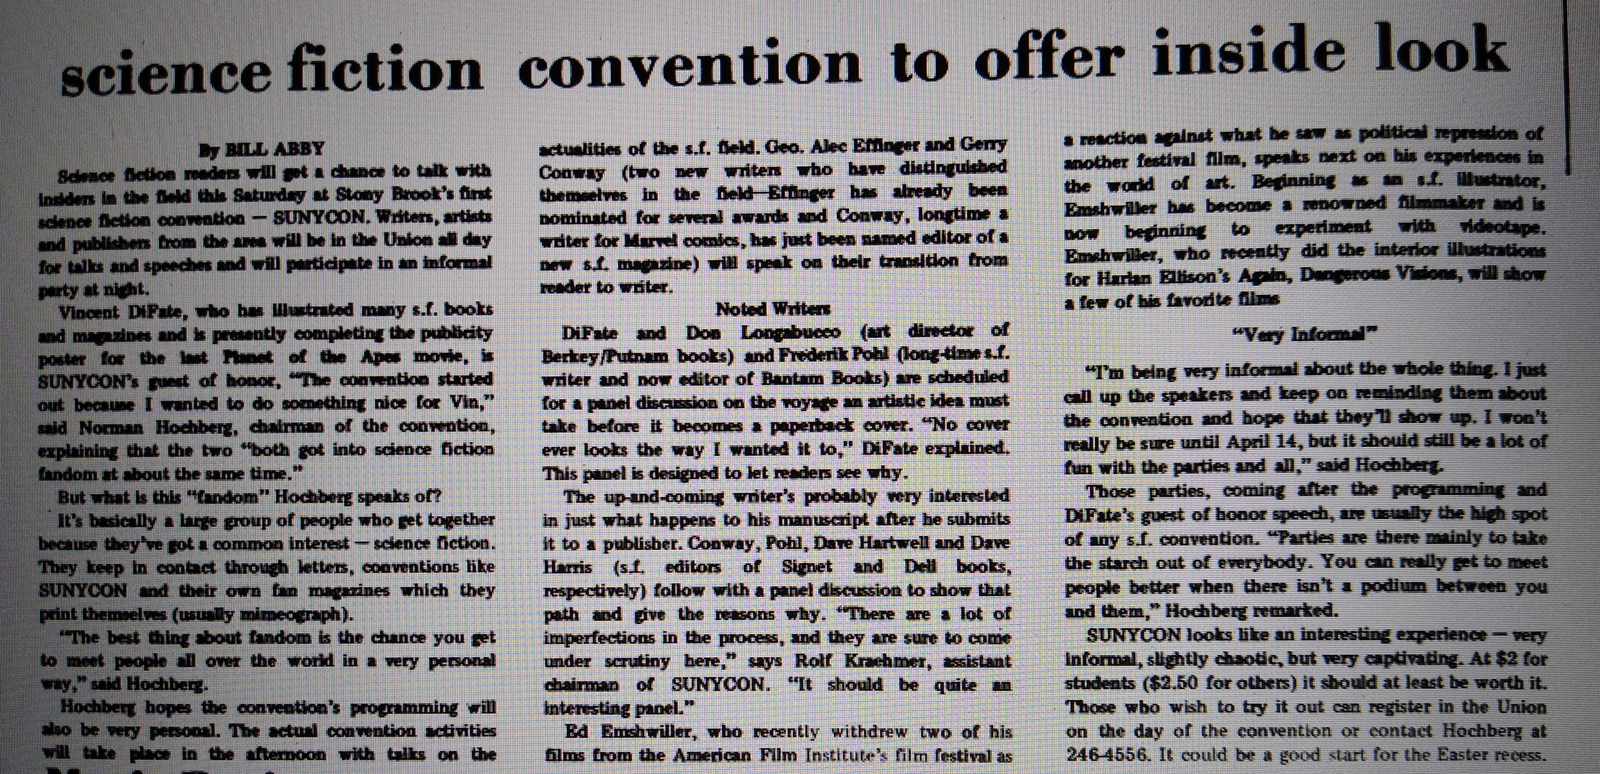
«science fiction convention to offer inside look
By BILL ARBY

Science fiction readers will get a chance to talk with insiders in the field this Saturday at Stony Brook's first science fiction convention - SUNYCON. Writers, artists and publishers from the area will be in the union all day for talks and speeches and will participate in an informal party at night.
Vincent DiFate, who has illustrated many s.f. books and magazines and is presently completing the publicity poster for the last Planet of the Apes movie, is SUNYCON's guest of honor, "The convention started out because I wanted to do something nice for Vin," said Norman Hocberg, chairman of the convention, explaining that the two "both got into science fiction fandom at about the same time."
But what is this fandom Hochberg speaks of?
It's basically a large group of people who get together because they've got a common interest - science fiction. They keep in contact through letters, conventions like SUNYCON and their own fan magazines which they print themselves (usually mimeograph).
"The best thing about fandom is the chance you get to meet people all over the world in a very personal way," said Hochberg.
Hochberg hopes the conventions programming will also be very personal.
The actual convention activities will take place in the afternoon with talks on the actualities of the s.f. field. Geo. Alec Effinger and Jerry Conway (two new writers who have distinguished themselves in the field - Effinger has already been nominated for several awards and Conway, longtime a writer for Marvel comics, has just been named editor of a new s.f. magazine) will speak on their transition from reader to writer.
Noted Writers
DiFate and Don Longabucco (art director of Berkeley/Putnam books) and Frederick Pohl (long time s.f. writer and now editor of Bantam Books) are scheduled for a panel discussion on the voyage an artistic idea must take before it becomes a paperback cover. "No cover ever looks the way I wanted it to," DiFfate explained. This panel is designed to let readers see why.
The up-and-coming writer's probably very interested in just what happens to his manuscript after you submit it to a publisher. Conway, Pohl, Dave Hartwell and Dave Harris (s.f. editors of Signet and Dell books, respectively) follow with a panel discussion to show that path and give the reasons why. "There are a lot of imperfections in the process, and they are sure to come under scrutiny here," says Rolf Kraehmer, assistant chairman of SUNYCON. "It should be quite an interesting panel."
Ed Enshwiller, who recently withdrew two of his films from the American Film institute's Film Festival as a reaction against what he saw as political repression of another Festival film, speaks next on his experiences in the world of art. Beginning as an SF illustrator, Enschwiller has become a renowned filmmaker and is now beginning to experiment with videotape. Enshwiller, who recently did the interior illustrations for Harlan Ellison's Again, Dangerous Visions, will show a few of his favorite films
"Very Informal"
"I'm being very informal about the whole thing. I just call up the speakers and keep on reminding them about the convention and hope that they'll show up. I won't really be sure until April 14th, but it should still be a lot of fun with the parties and all," said Hochberg. Those parties, coming after the programming and DiFate's guest of honor speech, are usually the high spot of any s.f. convention. "Parties are there mainly to take the starch out of everybody. You can really get to meet people better when there isn't a podium between you and them, " Hochberg remarked.
SUNYCON looks like an interesting experience - very informal, slightly chaotic, but very captivating. At $2 for students ($2.50 for others) it should be at least be worth it. Those who wish to try it out can register in he Union on the day of the convention or contact Hochberg at 246-4556. It could be a good start for the Easter recess.»

(from “SUNYCON April 13 1973” photo album of “ICON - To infinity and beyond!” Group on Facebook)

